# VISVESVARAYA TECHNOLOGICAL UNIVERSITY

**“JnanaSangama”, Belgaum -590014, Karnataka.**



## LAB REPORT

### on

Machine Learning (23CS6PCMAL)

#### Submitted by

**Sneha Prasanna(1BM22CS284)**

#### in partial fulfillment for the award of the degree of

**BACHELOR OF ENGINEERING**

***in***

## COMPUTER SCIENCE AND ENGINEERING



**B.M.S. COLLEGE OF ENGINEERING**

**(Autonomous Institution under VTU)**

## BENGALURU-560019

### Sep-2024 to Jan-2025

**B.M.S. College of Engineering,**

**Bull Temple Road, Bangalore 560019**

(Affiliated To Visvesvaraya Technological University, Belgaum)

**Department of Computer Science and Engineering**



##### CERTIFICATE

This is to certify that the Lab work entitled “Machine Learning (23CS6PCMAL)” carried out by **Sneha Prasanna (1BM22CS284),** who is bonafide student of **B.M.S. College of Engineering.** It is in partial fulfillment for the award of **Bachelor of Engineering in Computer Science and Engineering** of the Visvesvaraya Technological University, Belgaum. The Lab report has been approved as it satisfies the academic requirements in respect of an Machine Learning (23CS6PCMAL) work prescribed for the said degree.

**Dr. Kavitha Sooda** Professor & HOD

Department of CSE, BMSCE

**Lab Faculty Incharge**

Name: Sunayana S

Assistant Professor Department of CSE, BMSCE

# Index

|  |  |  |  |  |
| --- | --- | --- | --- | --- |
| **Sl.**  **No.** | **Date** | | **Experiment Title** | **Page No.** |
| 1 | 21-2-2025 | Write a python program to import and export data using Pandas library functions | | 1 |
| 2 | 3-3-2025 | Demonstrate various data pre-processing techniques for a given dataset | | 6 |
| 3 | 10-3-2025 | Implement Linear and Multi-Linear Regression algorithm using appropriate dataset | | 8 |
| 4 | 17-3-2025 | Build Logistic Regression Model for a given dataset | | 11 |
| 5 | 24-3-2025 | Use an appropriate data set for building the decision tree (ID3) and apply this knowledge to classify a new sample | | 19 |
| 6 | 7-4-2025 | Build KNN Classification model for a given dataset | | 23 |
| 7 | 21-4-2025 | Build Support vector machine model for a given dataset | | 30 |
| 8 | 5-5-2025 | Implement Random forest ensemble method on a given dataset | | 33 |
| 9 | 5-5-2025 | Implement Boosting ensemble method on a given dataset | | 37 |
| 10 | 12-5-2025 | Build k-Means algorithm to cluster a set of data stored in a .CSV file | | 40 |
| 11 | 12-5-2025 | Implement Dimensionality reduction using Principal Component Analysis (PCA) method | | 43 |

**Github Link:**

https://github.com/SnehaPrasanna1/ML-LAB-.git

##### Program 1

Write a python program to import and export data using Pandas library functions

Screenshots:

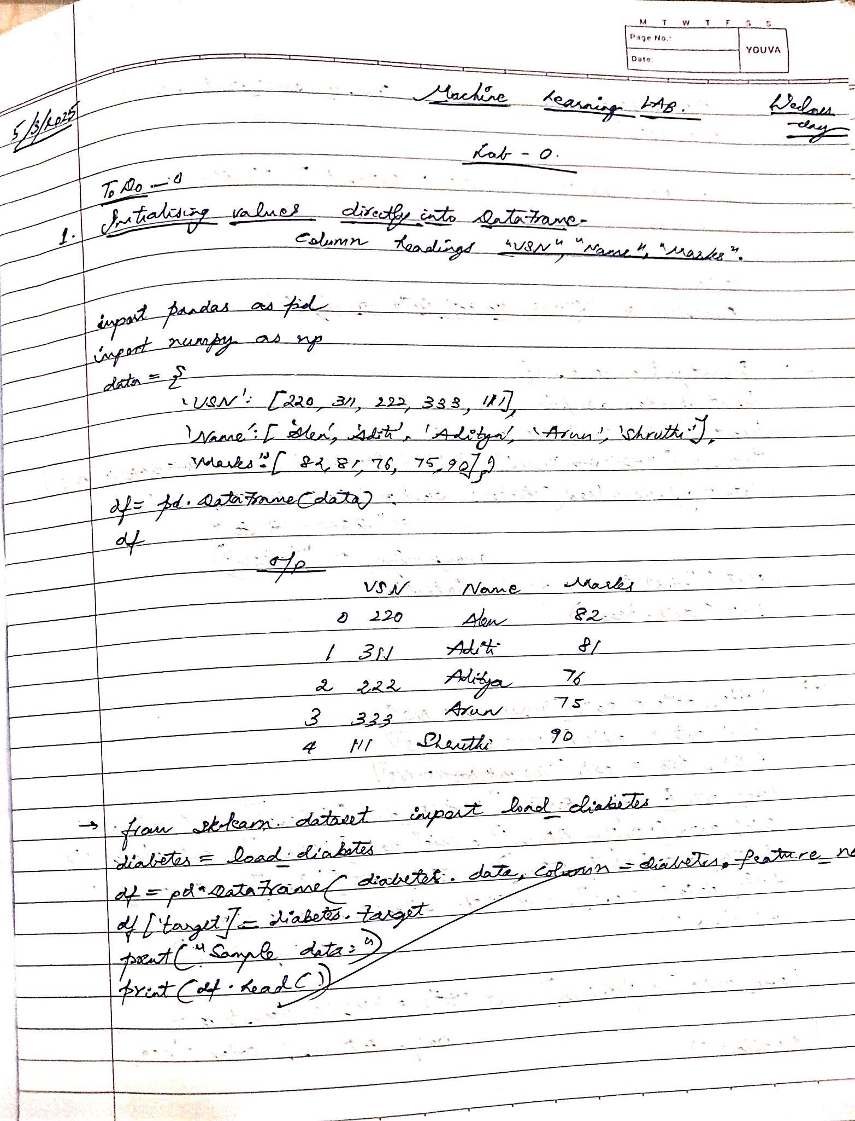

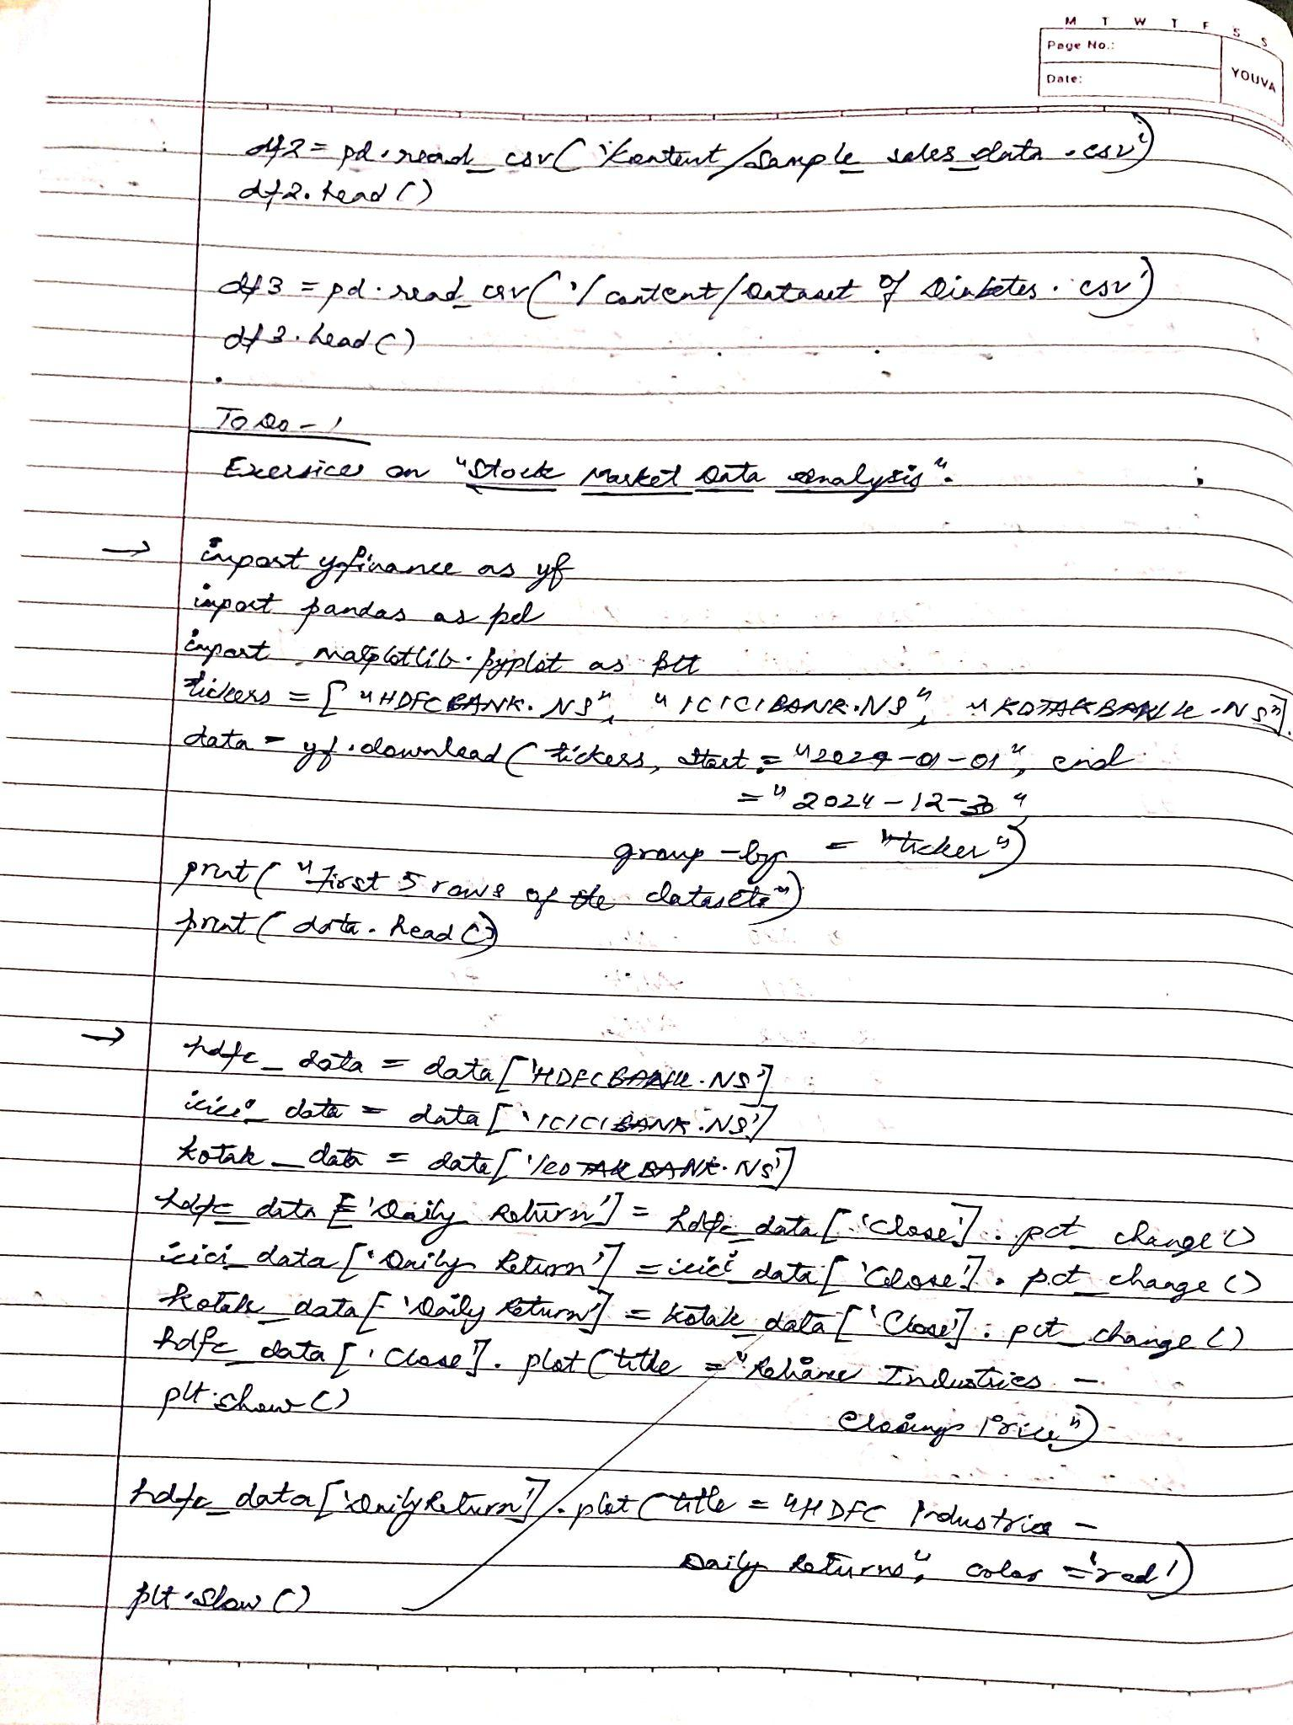

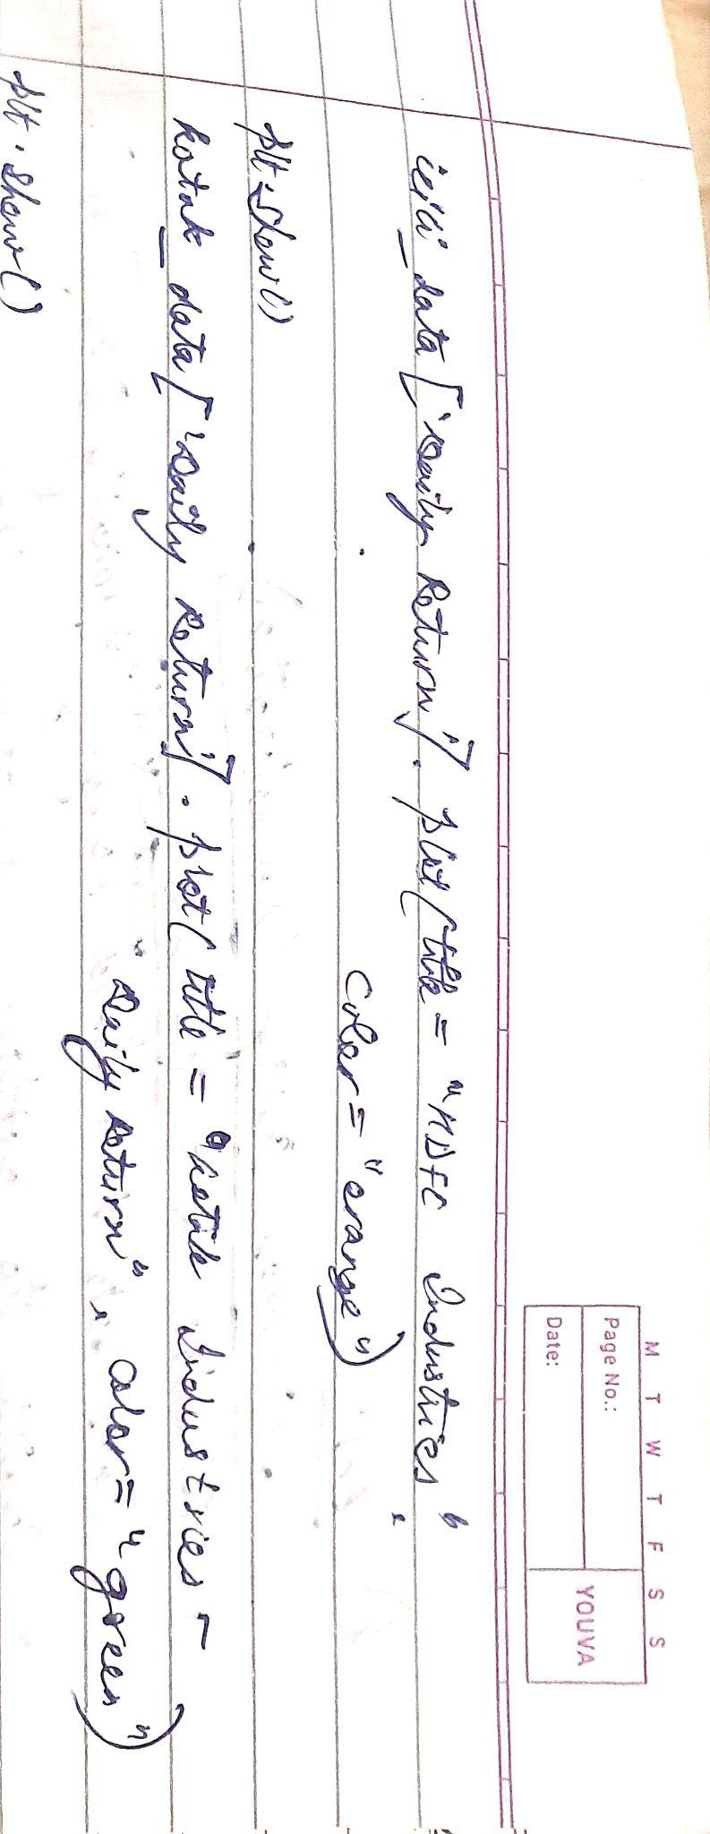

Code:

import pandas as pd

# Method-1: Initializing values directly into DataFrame

data_method1 = {'USN': ['1JS17CS001', '1JS17CS002', '1JS17CS003', '1JS17CS004', '1JS17CS005'],

'Name': ['Alice', 'Bob', 'Charlie', 'David', 'Eve'], 'Marks': [90, 85, 92, 78, 88]}

df_method1 = pd.DataFrame(data_method1)

print("Method-1:")

print(df_method1)

print("-" * 20)

# Method-2: Importing datasets from sklearn.datasets

from sklearn.datasets import load_diabetes

diabetes_data = load_diabetes()

df_method2 = pd.DataFrame(data=diabetes_data.data,

columns=diabetes_data.feature_names)

df_method2['target'] = diabetes_data.target

print("Method-2:")

print(df_method2.head())

print("-" * 20)

# Method-3: Importing datasets from a specific .csv file

try:

df_method3 = pd.read_csv('sample_sales_data.csv')

print("Method-3:")

print(df_method3.head())

print("-" * 20)

except FileNotFoundError:

print("sample_sales_data.csv not found. Please upload the file.") print("-" * 20)

import yfinance as yf

import matplotlib.pyplot as plt

tickers = ["HDFCBANK.NS", "ICICIBANK.NS", "KOTAKBANK.NS"]

start_date = "2024-01-01"

end_date = "2024-12-30"

data = yf.download(tickers, start=start_date, end=end_date) closing_prices = data['Close']

daily_returns = closing_prices.pct_change().dropna()

plt.figure(figsize=(12, 6))

closing_prices.plot()

plt.title('Closing Prices (2024)')

plt.xlabel('Date')

plt.ylabel('Price (INR)')

plt.grid(True)

plt.show()

plt.figure(figsize=(12, 6))

daily_returns.plot()

plt.title('Daily Returns (2024)')

plt.xlabel('Date')

plt.ylabel('Daily Return')

plt.grid(True)

plt.show()

##### Program 2

Demonstrate various preprocessing techniques for a given dataset

Screenshots:

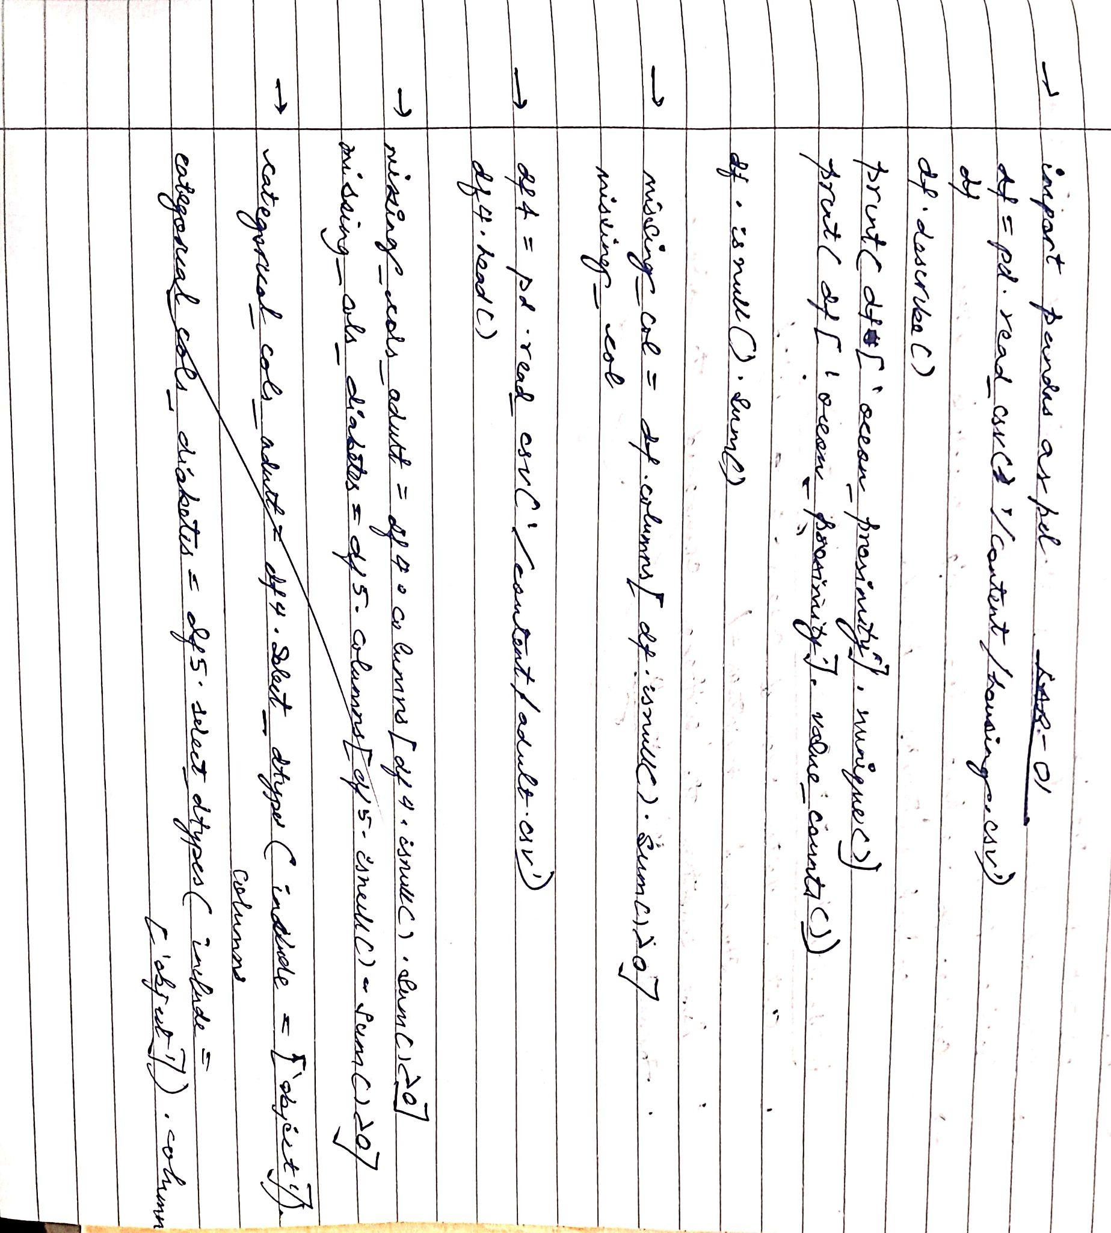

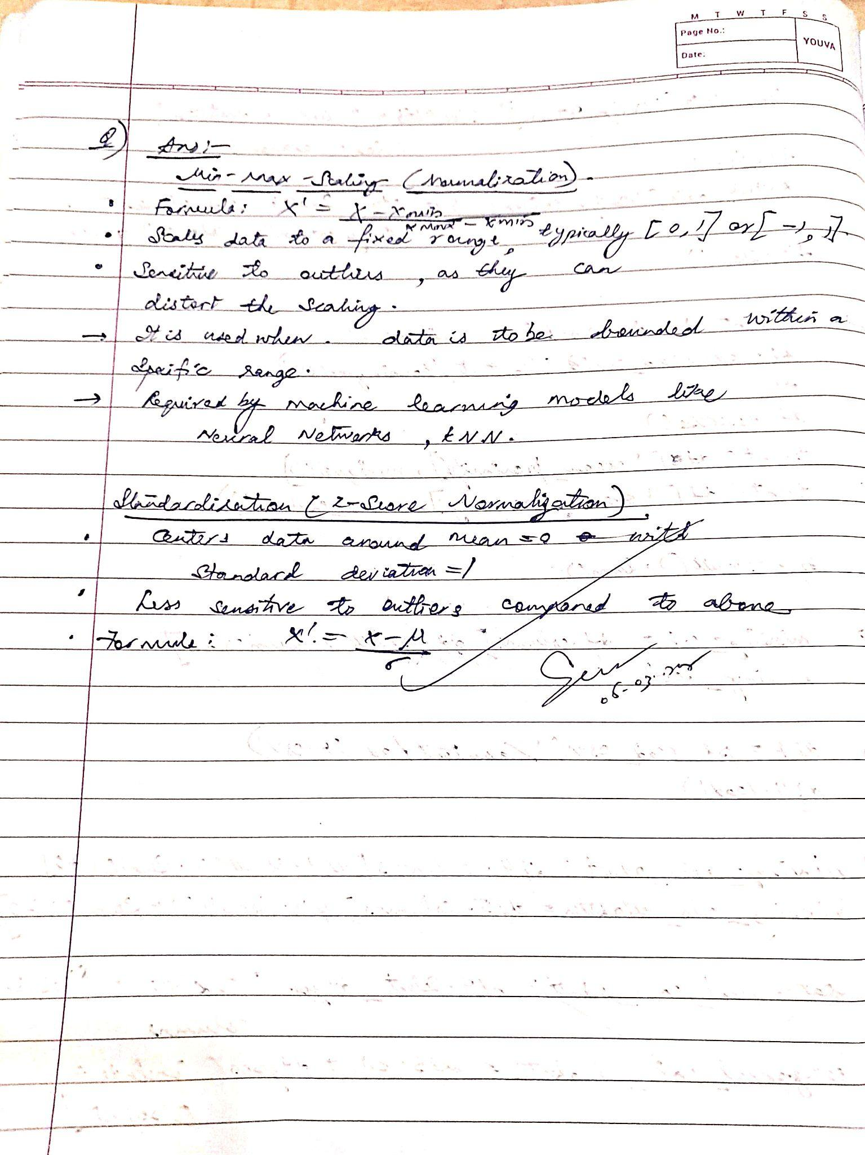

Code:

missing_col=df.columns[df.isnull().sum()>0]

missing_col

Index(['total_bedrooms'], dtype='object')

# For 'adult.csv' (df4)

missing_cols_adult = df4.columns[df4.isnull().sum() > 0]

print(f"Columns with missing values in 'adult.csv': {missing_cols_adult.tolist()}")

# For 'Dataset of Diabetes .csv' (df5)

missing_cols_diabetes = df5.columns[df5.isnull().sum() > 0]

print(f"Columns with missing values in 'Dataset of Diabetes .csv': {missing_cols_diabetes.tolist()}")

Columns with missing values in 'adult.csv': []

Columns with missing values in 'Dataset of Diabetes .csv': []

# For 'adult.csv' (df4)

categorical_cols_adult = df4.select_dtypes(include=['object']).columns

print(f"Categorical columns in 'adult.csv': {categorical_cols_adult.tolist()}")

# For 'Dataset of Diabetes .csv' (df5)

categorical_cols_diabetes = df5.select_dtypes(include=['object']).columns

print(f"Categorical columns in 'Dataset of Diabetes .csv': {categorical_cols_diabetes.tolist()}")

Categorical columns in 'adult.csv': ['workclass', 'education', 'marital-status', 'occupation', 'relationship', 'race', 'gender', 'native-country', 'income']

Categorical columns in 'Dataset of Diabetes .csv': ['Gender', 'CLASS']

**Program 3**

Implement Linear and Multi-Linear Regression algorithm using appropriate dataset

Screenshots:

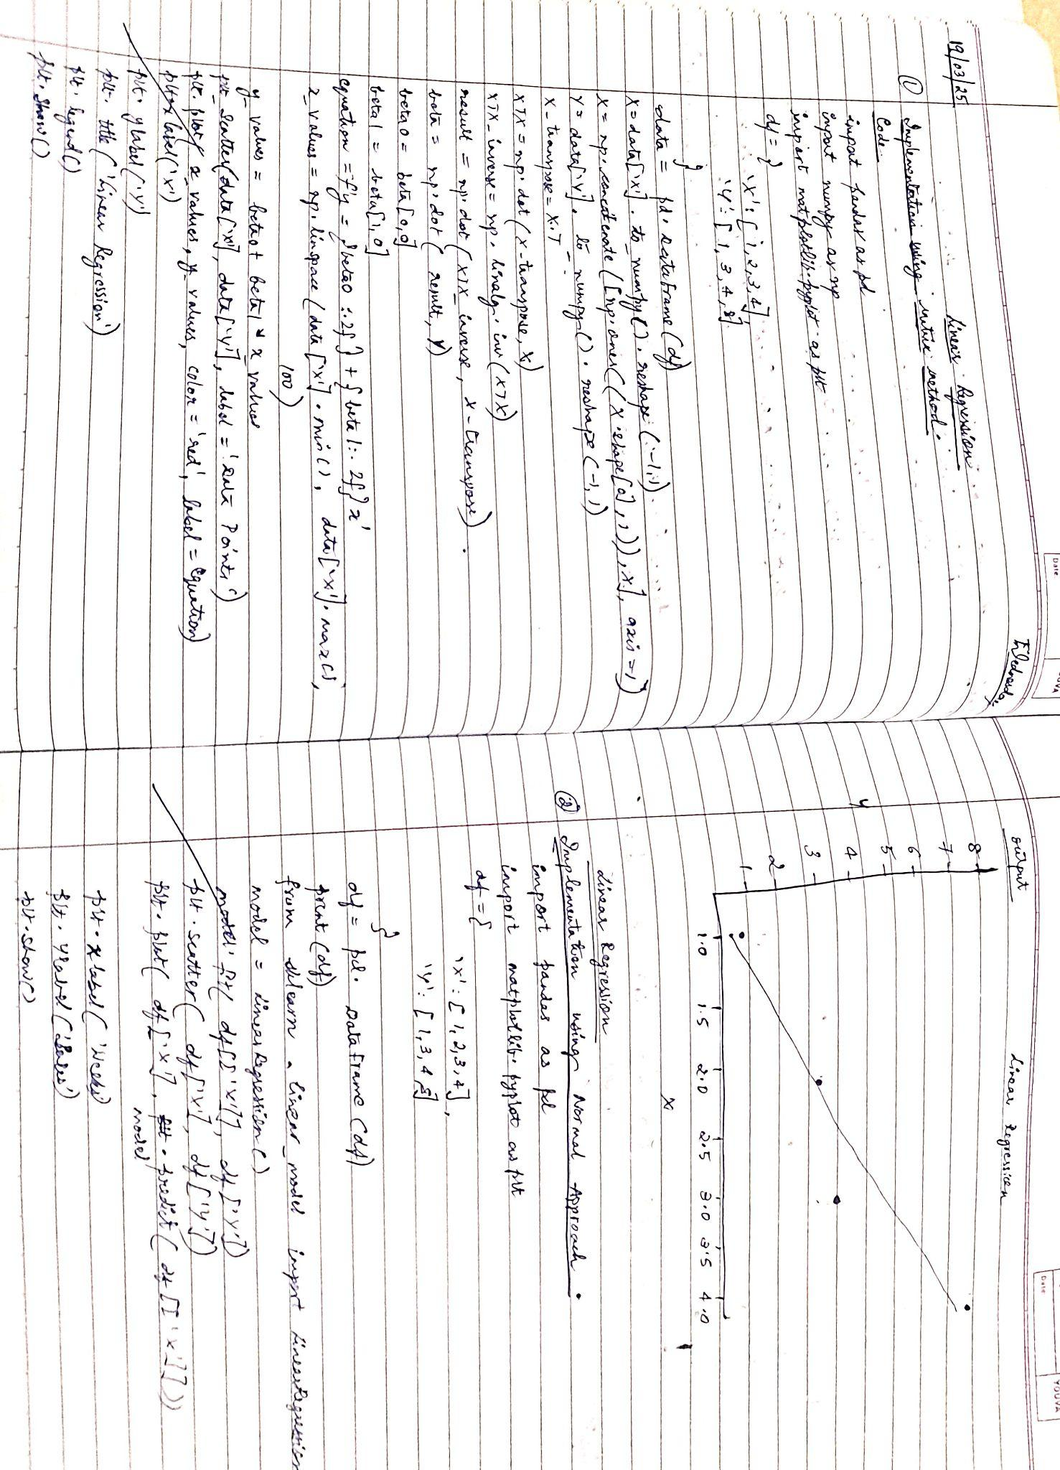

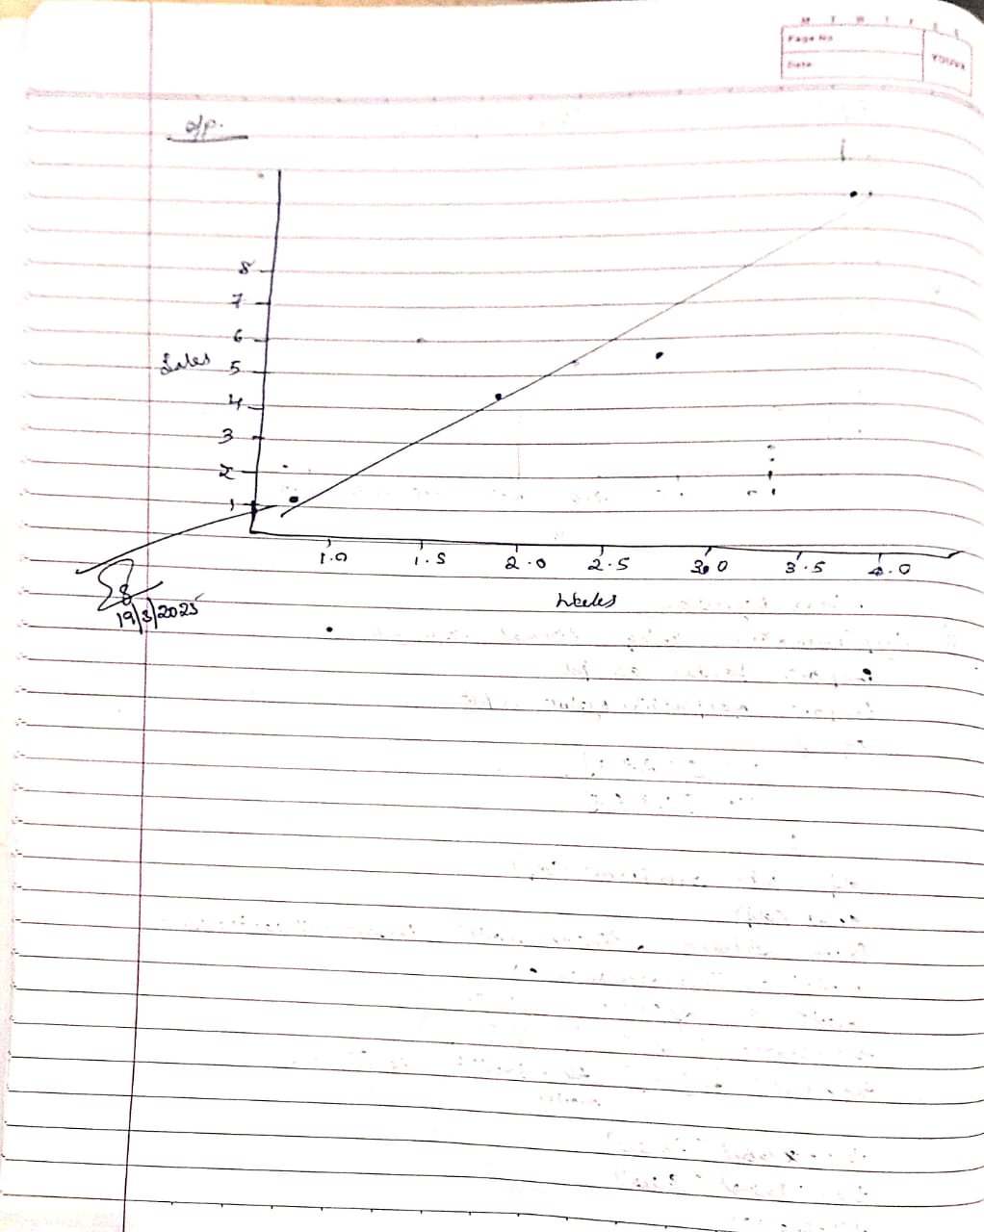

Linear Regression

Code:

import pandas as pd

import numpy as np

import matplotlib.pyplot as plt

# Sample data (replace with your actual data if needed)

df = {

'X': [1, 2, 3, 4],

'Y': [1, 3, 4, 8]

}

data = pd.DataFrame(df)

# Prepare X and Y

X = data['X'].to_numpy().reshape(-1, 1)

X = np.concatenate([np.ones((X.shape[0], 1)), X], axis=1)

Y = data['Y'].to_numpy().reshape(-1, 1) # Reshape Y to a column vector

# Calculate (X^T * X)^-1 * X^T

X_transpose = X.T

XTX = np.dot(X_transpose, X)

XTX_inverse = np.linalg.inv(XTX)

result = np.dot(XTX_inverse, X_transpose)

# Multiply with Y to get the coefficients and store in 'beta'

beta = np.dot(result, Y) # Changed variable name to 'beta'

# --- Writing the equation and plotting ---

# Extract beta values

beta0 = beta[0, 0] # Intercept

beta1 = beta[1, 0] # Slope

# Create the equation string

equation = f'y = {beta0:.2f} + {beta1:.2f}x'

# Generate points for the regression line

x_values = np.linspace(data['X'].min(), data['X'].max(), 100) # 100 points

y_values = beta0 + beta1 * x_values

# Plotting

plt.scatter(data['X'], data['Y'], label='Data Points') # Scatter plot of data

plt.plot(x_values, y_values, color='red', label=equation) # Regression line

plt.xlabel('X')

plt.ylabel('Y')

plt.title('Linear Regression')

plt.legend()

plt.show()

output:

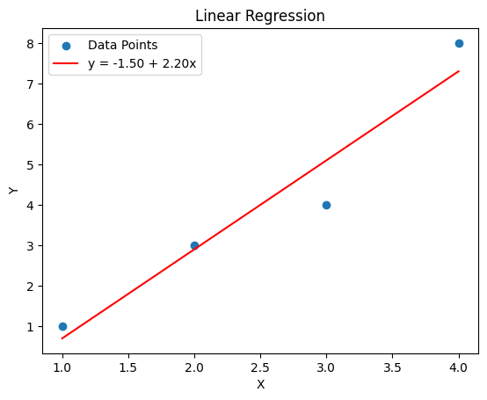

**Program 4**

Build Logistic Regression Model for a given dataset

Code:

#HR dataset

import pandas as pd

import matplotlib.pyplot as plt

import seaborn as sns

from sklearn.model_selection import train_test_split

from sklearn.preprocessing import StandardScaler, LabelEncoder

from sklearn.linear_model import LogisticRegression

from sklearn.metrics import accuracy_score, classification_report

df = pd.read_csv("HR.csv")

print(df.head())

missing_values = df.isnull().sum()

# Display columns with missing values

print(missing_values[missing_values > 0])

# Set seaborn style

sns.set_style("whitegrid")

# Plot bar chart for salary vs retention

plt.figure(figsize=(8, 5))

sns.countplot(x="salary", hue="left", data=df, palette="viridis")

plt.xlabel("Salary Level")

plt.ylabel("Count of Employees")

plt.title("Impact of Salary on Employee Retention")

plt.legend(["Stayed", "Left"])

plt.show()

# Plot bar chart for department vs retention

plt.figure(figsize=(12, 5))

sns.countplot(y="Department", hue="left", data=df, palette="coolwarm", order=df["Department"].value_counts().index)

plt.xlabel("Count of Employees")

plt.ylabel("Department")

plt.title("Correlation Between Department and Employee Retention")

plt.legend(["Stayed", "Left"])

plt.show()

# Encode categorical variables

label_encoders = {}

for col in ["salary", "Department"]:

le = LabelEncoder()

df[col] = le.fit_transform(df[col])

label_encoders[col] = le

# Select relevant features

features = ["satisfaction_level", "last_evaluation", "number_project", "average_montly_hours",

"time_spend_company", "Work_accident", "promotion_last_5years", "salary", "Department"]

X = df[features]

y = df["left"]

# Split data into train and test sets

X_train, X_test, y_train, y_test = train_test_split(X, y, test_size=0.2, random_state=42)

# Standardize the numerical features

scaler = StandardScaler()

X_train = scaler.fit_transform(X_train)

X_test = scaler.transform(X_test)

# Train logistic regression model

log_reg = LogisticRegression()

log_reg.fit(X_train, y_train)

# Predict on test set

y_pred = log_reg.predict(X_test)

# Measure accuracy

accuracy = accuracy_score(y_test, y_pred)

classification_rep = classification_report(y_test, y_pred)

# Print results

print(f"Model Accuracy: {accuracy:.4f}")

print("Classification Report:")

print(classification_rep)

output:

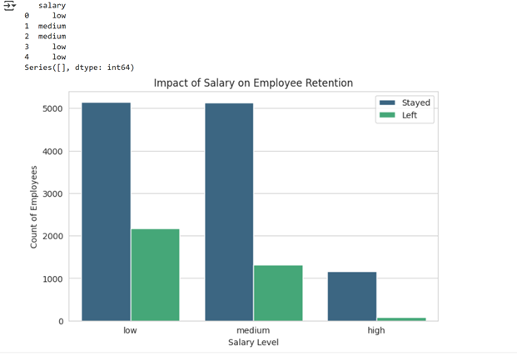

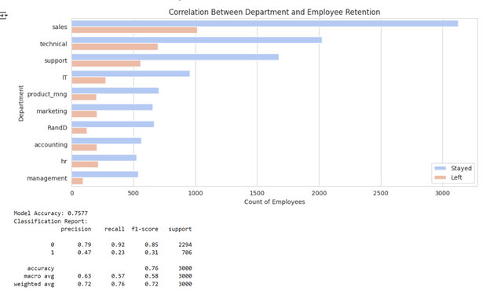

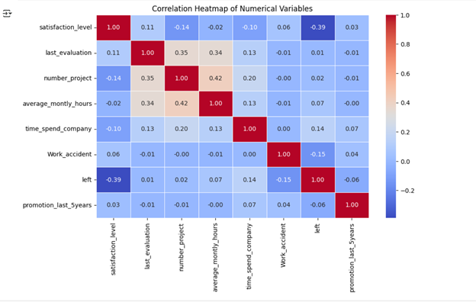

Code for logistic regression for multi classification:

import pandas as pd

import numpy as np

import matplotlib.pyplot as plt

import seaborn as sns

from sklearn.model_selection import train_test_split

from sklearn.preprocessing import StandardScaler

from sklearn.linear_model import LogisticRegression

from sklearn.metrics import accuracy_score, confusion_matrix, classification_report

# Load the dataset

df_zoo = pd.read_csv("zoo.csv")

# Drop 'animal_name' as it's not useful for classification

df_zoo = df_zoo.drop(columns=["animal_name"])

# Separate features and target variable

X = df_zoo.drop(columns=["class_type"]) # Features

y = df_zoo["class_type"] # Target (class type)

# Split dataset into training and testing sets

X_train, X_test, y_train, y_test = train_test_split(X, y, test_size=0.2, random_state=42, stratify=y)

# Standardize numerical features

scaler = StandardScaler()

X_train = scaler.fit_transform(X_train)

X_test = scaler.transform(X_test)

# Train multinomial logistic regression model

model = LogisticRegression(multi_class="multinomial", max_iter=1000)

model.fit(X_train, y_train)

# Make predictions

y_pred = model.predict(X_test)

# Measure accuracy

accuracy = accuracy_score(y_test, y_pred)

print(f"Model Accuracy: {accuracy:.4f}")

# Print classification report

print("Classification Report:\n", classification_report(y_test, y_pred))

# Generate confusion matrix

conf_matrix = confusion_matrix(y_test, y_pred)

# Plot confusion matrix

plt.figure(figsize=(8, 6))

sns.heatmap(conf_matrix, annot=True, fmt="d", cmap="Blues", xticklabels=np.unique(y), yticklabels=np.unique(y))

plt.xlabel("Predicted Class")

plt.ylabel("Actual Class")

plt.title("Confusion Matrix for Zoo Dataset")

plt.show()

Output:

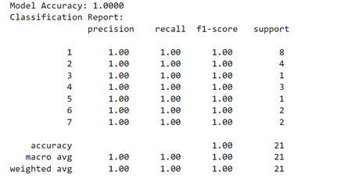

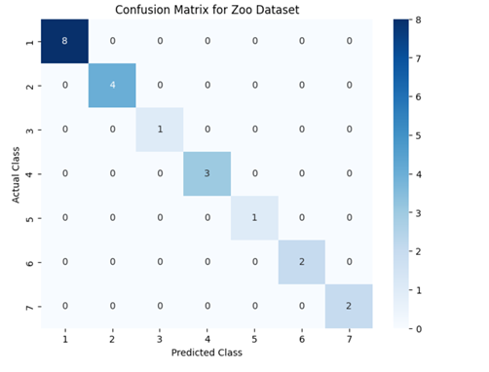

**Program 5**

Use an appropriate data set for building the decision tree (ID3) and apply this knowledge to classify a new sample

Screenshot:

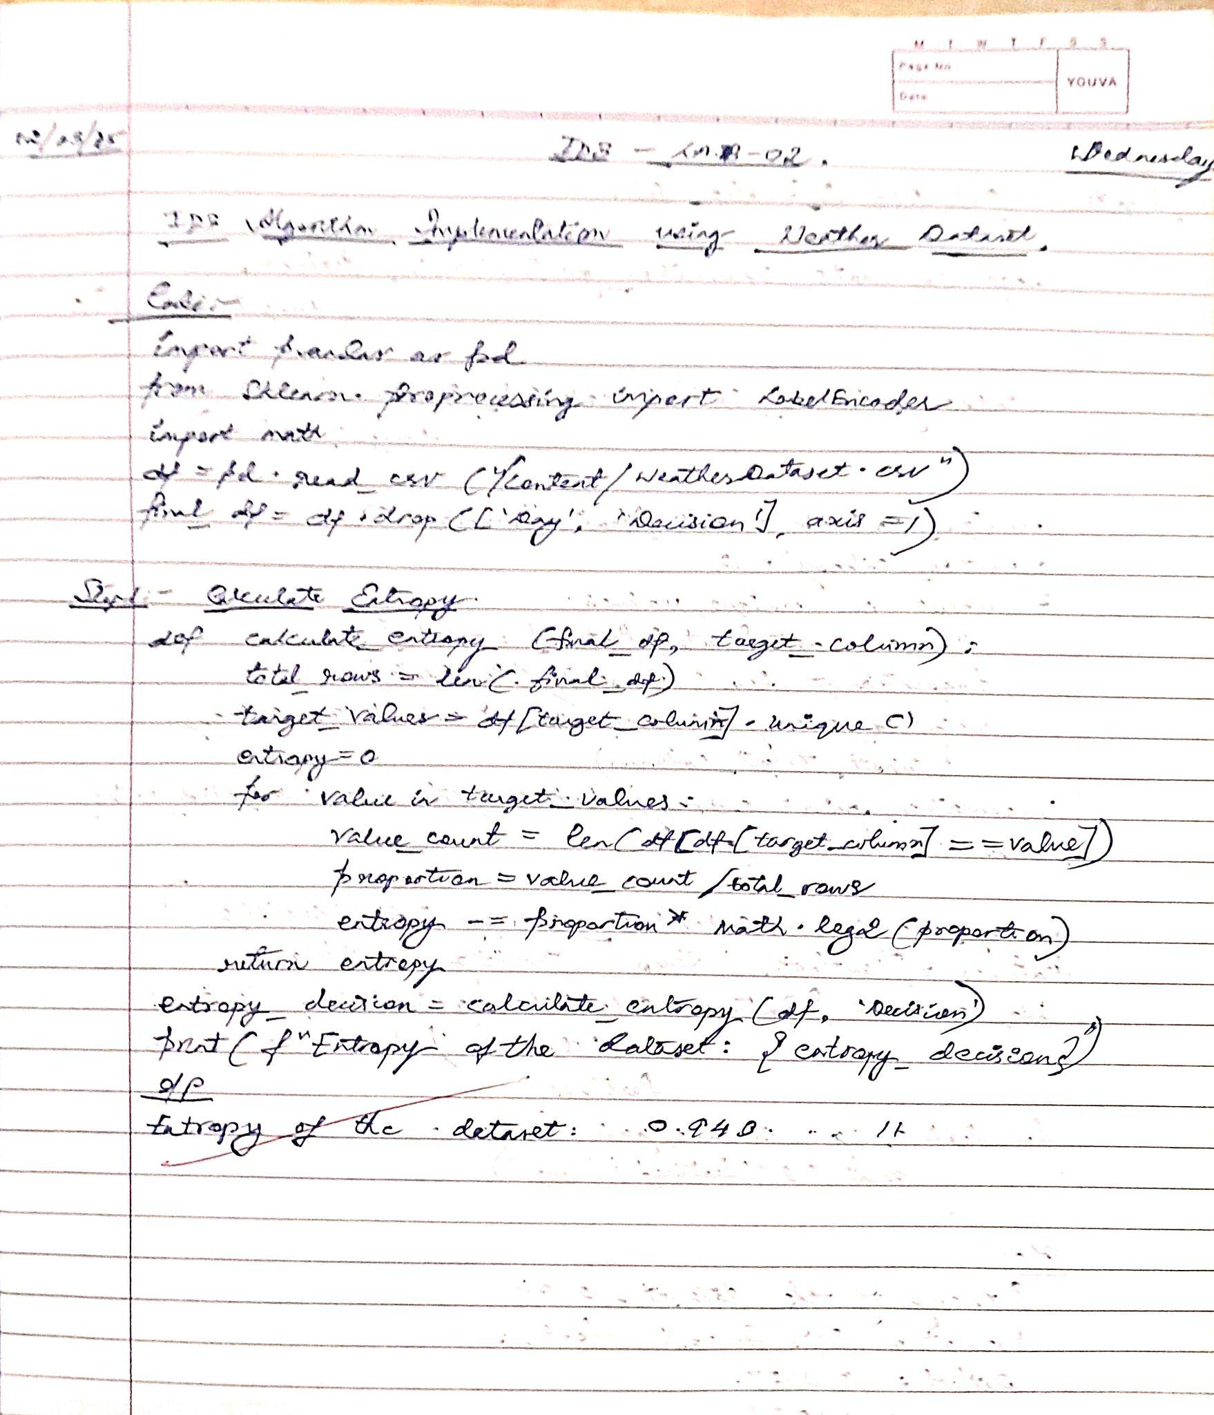



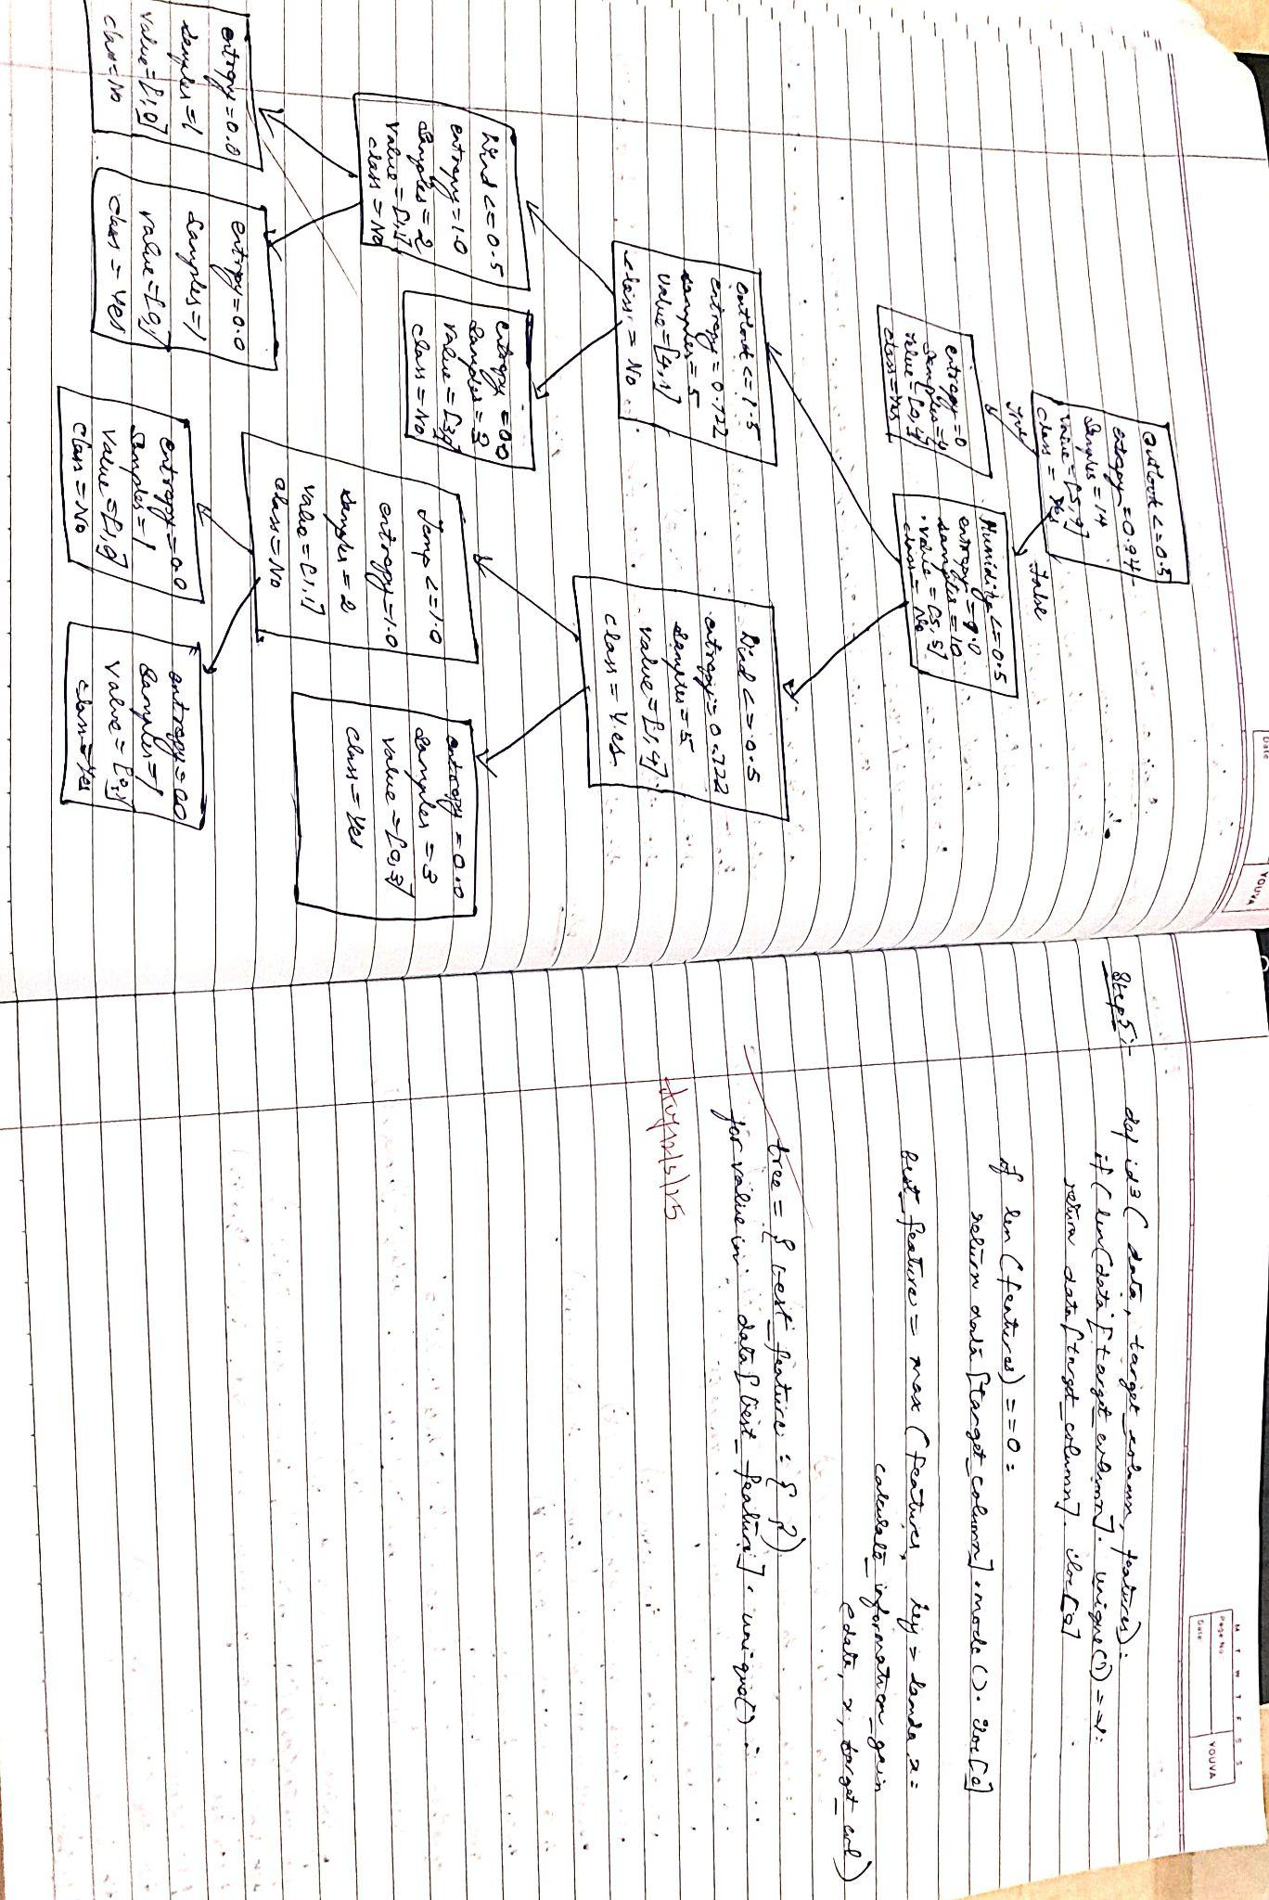

Code:

import pandas as pd

import matplotlib.pyplot as plt

from sklearn.tree import DecisionTreeClassifier, plot_tree

from sklearn.preprocessing import LabelEncoder

# Load dataset

df = pd.read_csv("/content/WeatherDataset.csv")

# Drop 'Day' column since it's irrelevant for decision-making

df = df.drop(['Day'], axis=1)

# Encode categorical variables into numerical values

label_encoders = {}

for column in df.columns:

le = LabelEncoder()

df[column] = le.fit_transform(df[column])

label_encoders[column] = le # Store encoders for later decoding

# Features (X) and Target (y)

X = df.drop(columns=['Decision']) # Features

y = df['Decision'] # Target variable

# Create a decision tree with more iterations (increased depth)

clf = DecisionTreeClassifier(criterion='entropy', max_depth=4, random_state=42) # Increased depth

clf.fit(X, y)

# Get class labels from the encoder

class_names = label_encoders['Decision'].classes_

feature_names = X.columns # Use all feature names

# Plot the decision tree

plt.figure(figsize=(12, 8))

plot_tree(clf, feature_names=feature_names, class_names=class_names, filled=True, rounded=True, fontsize=10)

plt.title("Decision Tree for Weather Dataset", fontsize=14)

plt.show()

Output:

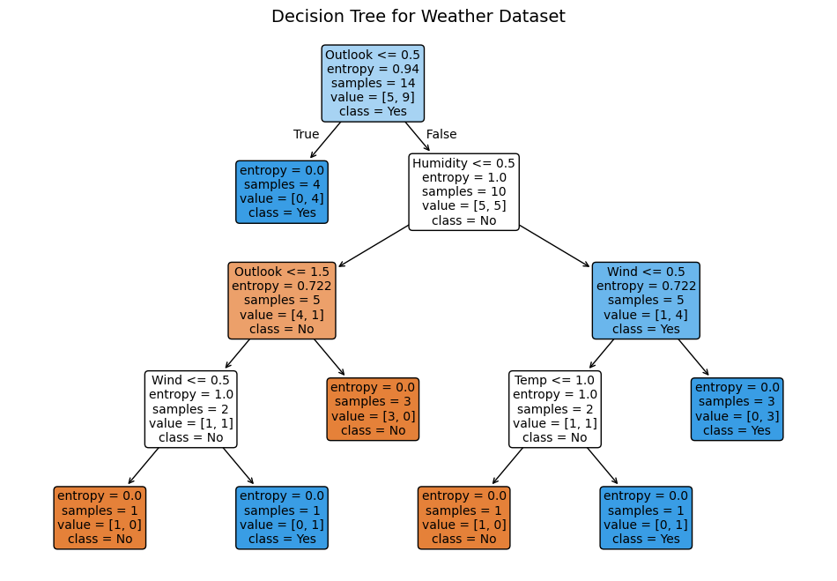

**Program 6**

Build KNN Classification model for a given dataset.

Screenshots:

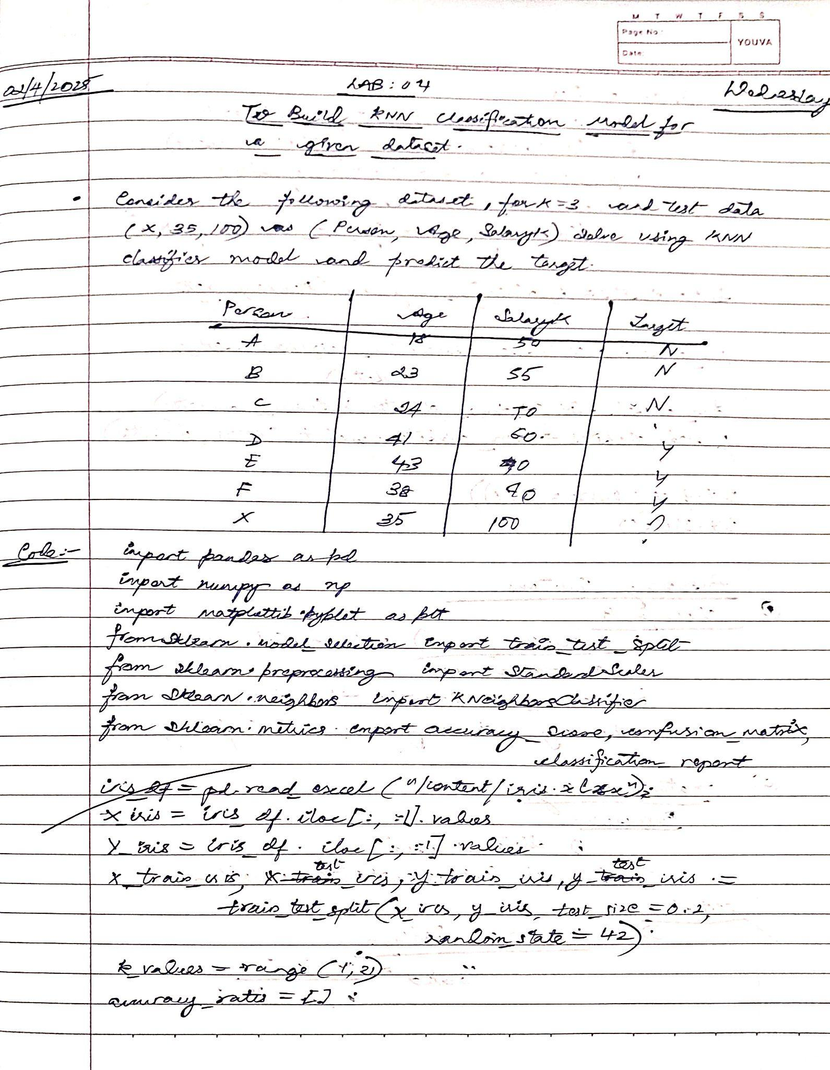



Code:

*# Import necessary libraries*

import pandas as pd

import numpy as np

import matplotlib.pyplot as plt

from sklearn.model_selection import train_test_split

from sklearn.preprocessing import StandardScaler

from sklearn.neighbors import KNeighborsClassifier

from sklearn.metrics import accuracy_score, confusion_matrix, classification_report

*### Task 1: KNN Classifier for the IRIS Dataset ###*

*# Load the Iris dataset from Excel using pd.read_excel*

iris_df = pd.read_excel("/content/iris.xlsx") *# Changed to pd.read_excel to correctly read .xlsx files*

*# Splitting features (X) and target (y)*

X_iris = iris_df.iloc[:, :-1].values *# Features*

y_iris = iris_df.iloc[:, -1].values *# Target*

*# Split the dataset (80% training, 20% testing)*

X_train_iris, X_test_iris, y_train_iris, y_test_iris = train_test_split(X_iris, y_iris, test_size=0.2, random_state=42)

*# Choosing the best k value*

k_values = range(1, 21)

accuracy_rates = []

for k in k_values:

knn = KNeighborsClassifier(n_neighbors=k)

knn.fit(X_train_iris, y_train_iris)

y_pred = knn.predict(X_test_iris)

accuracy_rates.append(accuracy_score(y_test_iris, y_pred))

*# Best k value based on highest accuracy*

best_k = k_values[np.argmax(accuracy_rates)]

print(f"Optimal k value for IRIS dataset: {best_k}")

*# Train final model with best k*

knn_iris = KNeighborsClassifier(n_neighbors=best_k)

knn_iris.fit(X_train_iris, y_train_iris)

y_pred_iris = knn_iris.predict(X_test_iris)

*# Display evaluation metrics*

print("\nAccuracy Score (IRIS Dataset):", accuracy_score(y_test_iris, y_pred_iris))

print("\nConfusion Matrix (IRIS Dataset):\n", confusion_matrix(y_test_iris, y_pred_iris))

print("\nClassification Report (IRIS Dataset):\n", classification_report(y_test_iris, y_pred_iris))

*# Plot accuracy vs k*

plt.figure(figsize=(8, 4))

plt.plot(k_values, accuracy_rates, marker='o', linestyle='-', color='b')

plt.xlabel("Number of Neighbors (k)")

plt.ylabel("Accuracy")

plt.title("Accuracy vs k for KNN (IRIS Dataset)")

plt.show()

*### Task 2: KNN Classifier for the Diabetes Dataset with Feature Scaling ###*

*# Load the Diabetes dataset from CSV*

diabetes_df = pd.read_csv("/content/diabetes.csv")

*# Splitting features (X) and target (y)*

X_diabetes = diabetes_df.iloc[:, :-1].values *# Features*

y_diabetes = diabetes_df.iloc[:, -1].values *# Target*

*# Split the dataset (80% training, 20% testing)*

X_train_diabetes, X_test_diabetes, y_train_diabetes, y_test_diabetes = train_test_split(X_diabetes, y_diabetes, test_size=0.2, random_state=42)

*# Feature Scaling (Standardization)*

scaler = StandardScaler()

X_train_diabetes = scaler.fit_transform(X_train_diabetes)

X_test_diabetes = scaler.transform(X_test_diabetes)

*# Choosing the best k value*

k_values = range(1, 21)

accuracy_rates_diabetes = []

for k in k_values:

knn = KNeighborsClassifier(n_neighbors=k)

knn.fit(X_train_diabetes, y_train_diabetes)

y_pred = knn.predict(X_test_diabetes)

accuracy_rates_diabetes.append(accuracy_score(y_test_diabetes, y_pred))

*# Best k value based on highest accuracy*

best_k_diabetes = k_values[np.argmax(accuracy_rates_diabetes)]

print(f"\nOptimal k value for DIABETES dataset: {best_k_diabetes}")

*# Train final model with best k*

knn_diabetes = KNeighborsClassifier(n_neighbors=best_k_diabetes)

knn_diabetes.fit(X_train_diabetes, y_train_diabetes)

y_pred_diabetes = knn_diabetes.predict(X_test_diabetes)

*# Display evaluation metrics*

print("\nAccuracy Score (Diabetes Dataset):", accuracy_score(y_test_diabetes, y_pred_diabetes))

print("\nConfusion Matrix (Diabetes Dataset):\n", confusion_matrix(y_test_diabetes, y_pred_diabetes))

print("\nClassification Report (Diabetes Dataset):\n", classification_report(y_test_diabetes, y_pred_diabetes))

*# Plot accuracy vs k*

plt.figure(figsize=(8, 4))

plt.plot(k_values, accuracy_rates_diabetes, marker='o', linestyle='-', color='r')

plt.xlabel("Number of Neighbors (k)")

plt.ylabel("Accuracy")

plt.title("Accuracy vs k for KNN (Diabetes Dataset)")

plt.show()

Output:

Optimal k value for IRIS dataset: 1

Accuracy Score (IRIS Dataset): 1.0

Confusion Matrix (IRIS Dataset):

[[10 0 0]

[ 0 9 0]

[ 0 0 11]]

Classification Report (IRIS Dataset):

precision recall f1-score support

setosa 1.00 1.00 1.00 10

versicolor 1.00 1.00 1.00 9

virginica 1.00 1.00 1.00 11

accuracy 1.00 30

macro avg 1.00 1.00 1.00 30

weighted avg 1.00 1.00 1.00 30

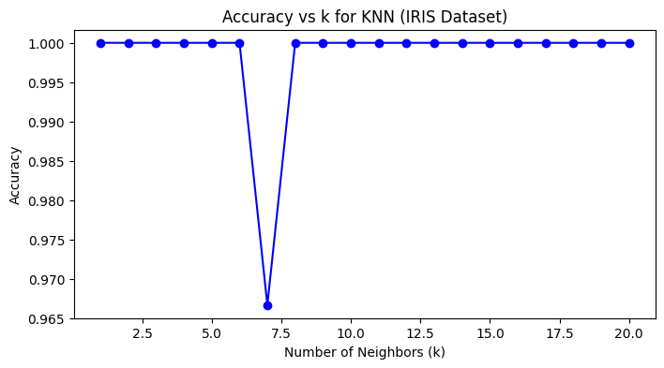

Optimal k value for DIABETES dataset: 18

Accuracy Score (Diabetes Dataset): 0.7597402597402597

Confusion Matrix (Diabetes Dataset):

[[88 11]

[26 29]]

Classification Report (Diabetes Dataset):

precision recall f1-score support

0 0.77 0.89 0.83 99

1 0.72 0.53 0.61 55

accuracy 0.76 154

macro avg 0.75 0.71 0.72 154

weighted avg 0.76 0.76 0.75 154

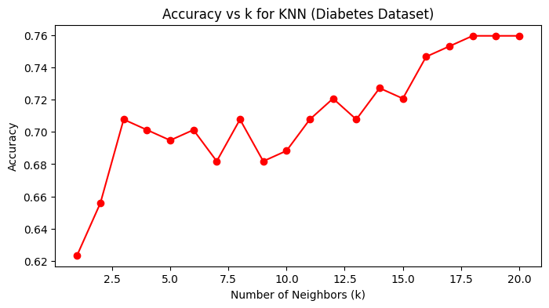

**Program 7**

Build Support vector machine model for a given dataset

Screenshots:

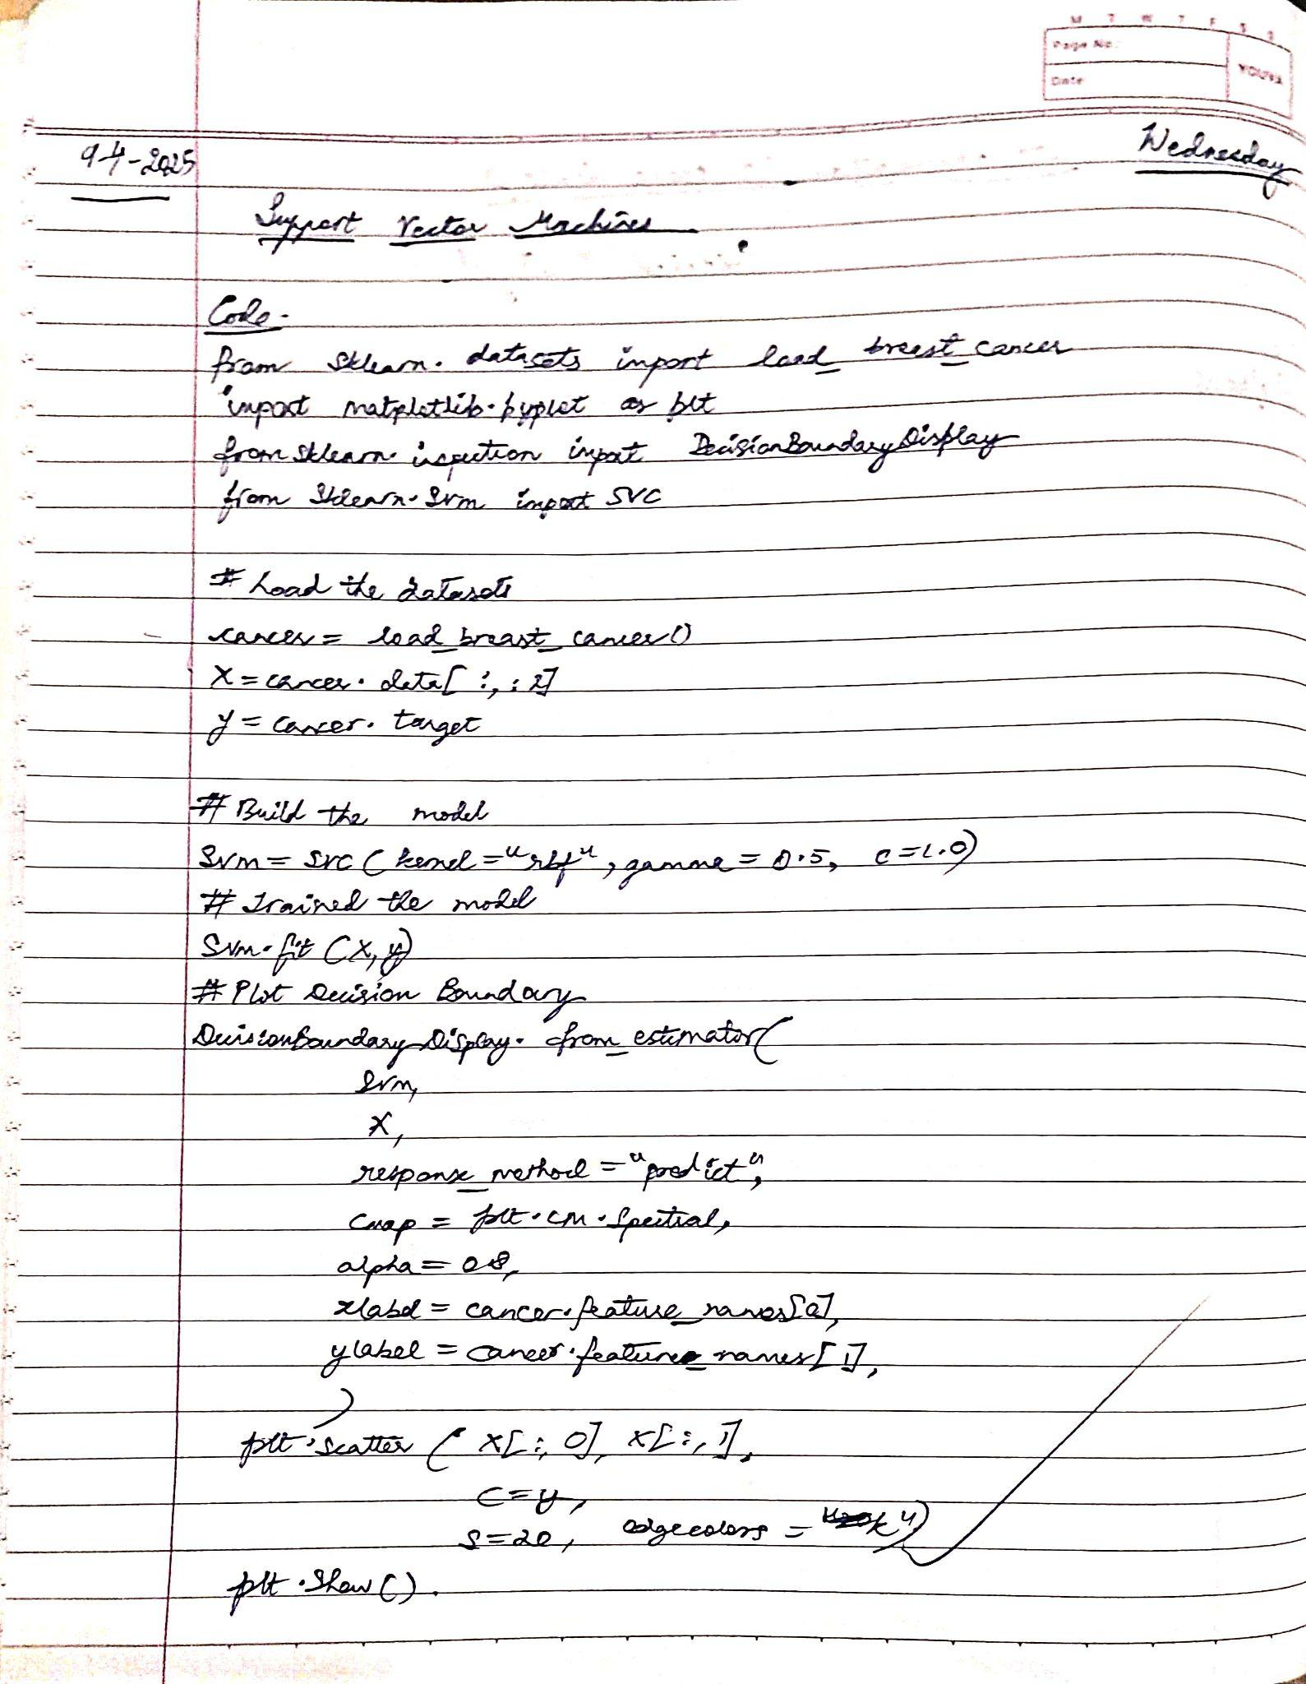

Code:

# Load the important packages

from sklearn.datasets import load_breast_cancer

import matplotlib.pyplot as plt

from sklearn.inspection import DecisionBoundaryDisplay

from sklearn.svm import SVC

# Load the datasets

cancer = load_breast_cancer()

X = cancer.data[:, :2]

y = cancer.target

#Build the model

svm = SVC(kernel="rbf", gamma=0.5, C=1.0)

# Trained the model

svm.fit(X, y)

# Plot Decision Boundary

DecisionBoundaryDisplay.from_estimator(

svm,

X,

response_method="predict",

cmap=plt.cm.Spectral,

alpha=0.8,

xlabel=cancer.feature_names[0],

ylabel=cancer.feature_names[1],

)

# Scatter plot

plt.scatter(X[:, 0], X[:, 1],

c=y,

s=20, edgecolors="k")

plt.show()

Output:

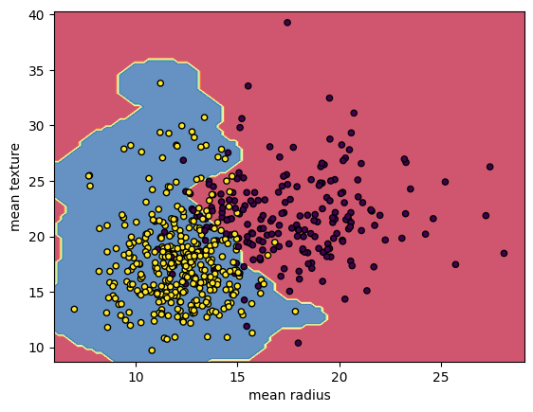

**Program 8**

Implement Random forest ensemble method on a given dataset.

Screenshots:

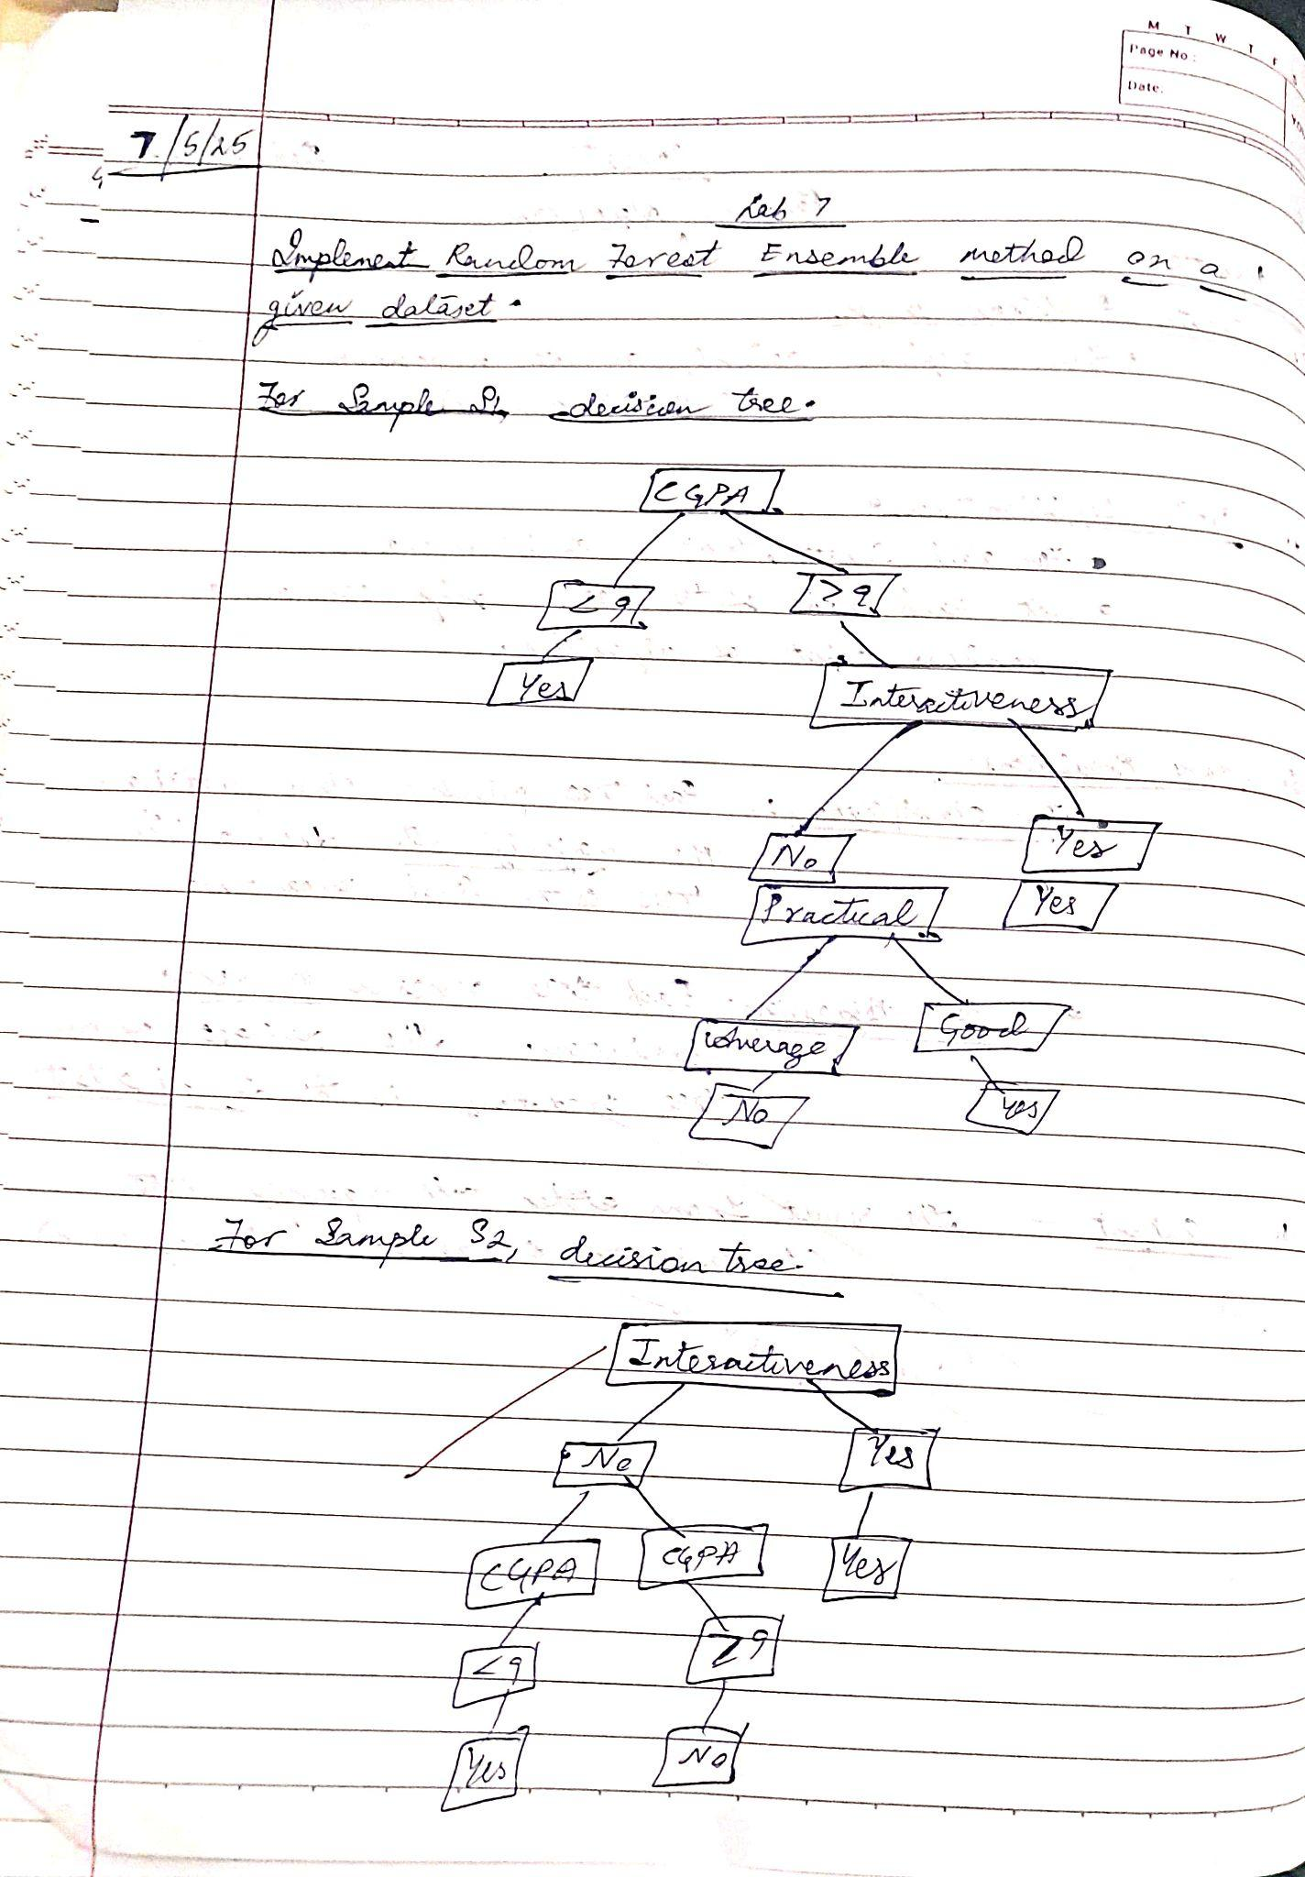

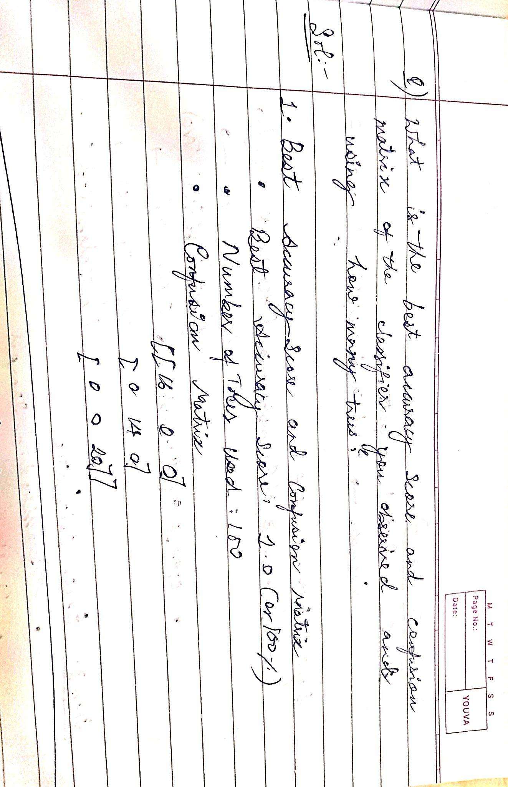

Code:

import pandas as pd

from sklearn.model_selection import train_test_split

from sklearn.ensemble import RandomForestClassifier

from sklearn.metrics import accuracy_score

import matplotlib.pyplot as plt

# Step 1: Load the dataset using pandas read_csv

# Replace the file path with the path to your CSV file

data = pd.read_csv('/content/iris (6).csv')

# Step 2: Inspect the first few rows of the dataset

print(data.head())

# Step 3: Preprocessing (assuming the target variable is in the last column)

X = data.iloc[:, :-1] # Feature matrix (all columns except the target column)

y = data.iloc[:, -1] # Target variable (last column)

# Step 4: Split the dataset into training and testing sets

X_train, X_test, y_train, y_test = train_test_split(X, y, test_size=0.3, random_state=42)

# Step 5: Initialize and train the Random Forest Classifier

rf_model = RandomForestClassifier(n_estimators=100, random_state=42)

rf_model.fit(X_train, y_train)

# Step 6: Make predictions on the test set

y_pred = rf_model.predict(X_test)

# Step 7: Evaluate the model performance using accuracy

accuracy = accuracy_score(y_test, y_pred)

print(f"Accuracy of Random Forest model: {accuracy * 100:.2f}%")

# Step 8: Feature Importance (Optional)

feature_importances = rf_model.feature_importances_

features = X.columns

# Plotting feature importances

plt.figure(figsize=(10, 6))

plt.barh(features, feature_importances, color='skyblue')

plt.xlabel('Feature Importance')

plt.title('Feature Importance in Random Forest Model')

plt.show()

# Step 9: Hyperparameter Tuning (Optional)

# If you want to perform hyperparameter tuning to optimize the model

from sklearn.model_selection import GridSearchCV

param_grid = {

'n_estimators': [100, 200, 300],

'max_depth': [None, 10, 20, 30],

'min_samples_split': [2, 5, 10],

'min_samples_leaf': [1, 2, 4]

}

# Initialize GridSearchCV

grid_search = GridSearchCV(estimator=rf_model, param_grid=param_grid, cv=5, n_jobs=-1, verbose=2)

grid_search.fit(X_train, y_train)

# Print the best parameters and best score

print(f"Best parameters found: {grid_search.best_params_}")

print(f"Best cross-validation score: {grid_search.best_score_:.2f}")

# Step 10: Evaluate the model with the best parameters

best_rf_model = grid_search.best_estimator_

y_pred_best = best_rf_model.predict(X_test)

accuracy_best = accuracy_score(y_test, y_pred_best)

print(f"Accuracy of tuned Random Forest model: {accuracy_best * 100:.2f}%")

Output:

sepal_length sepal_width petal_length petal_width species

0 5.1 3.5 1.4 0.2 setosa

1 4.9 3.0 1.4 0.2 setosa

2 4.7 3.2 1.3 0.2 setosa

3 4.6 3.1 1.5 0.2 setosa

4 5.0 3.6 1.4 0.2 setosa

Accuracy of Random Forest model: 100.00%

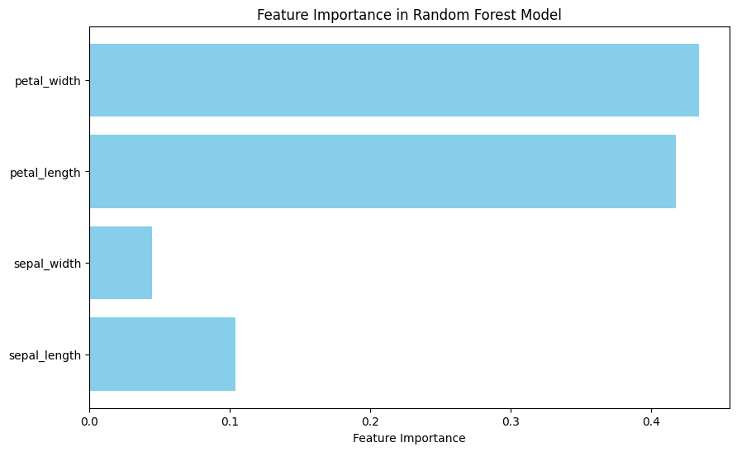

Fitting 5 folds for each of 108 candidates, totalling 540 fits

Best parameters found: {'max_depth': None, 'min_samples_leaf': 1, 'min_samples_split': 2, 'n_estimators': 100}

Best cross-validation score: 0.94

Accuracy of tuned Random Forest model: 100.00%

**Program 9**

Implement Boosting ensemble method on a given dataset

Screenshots:

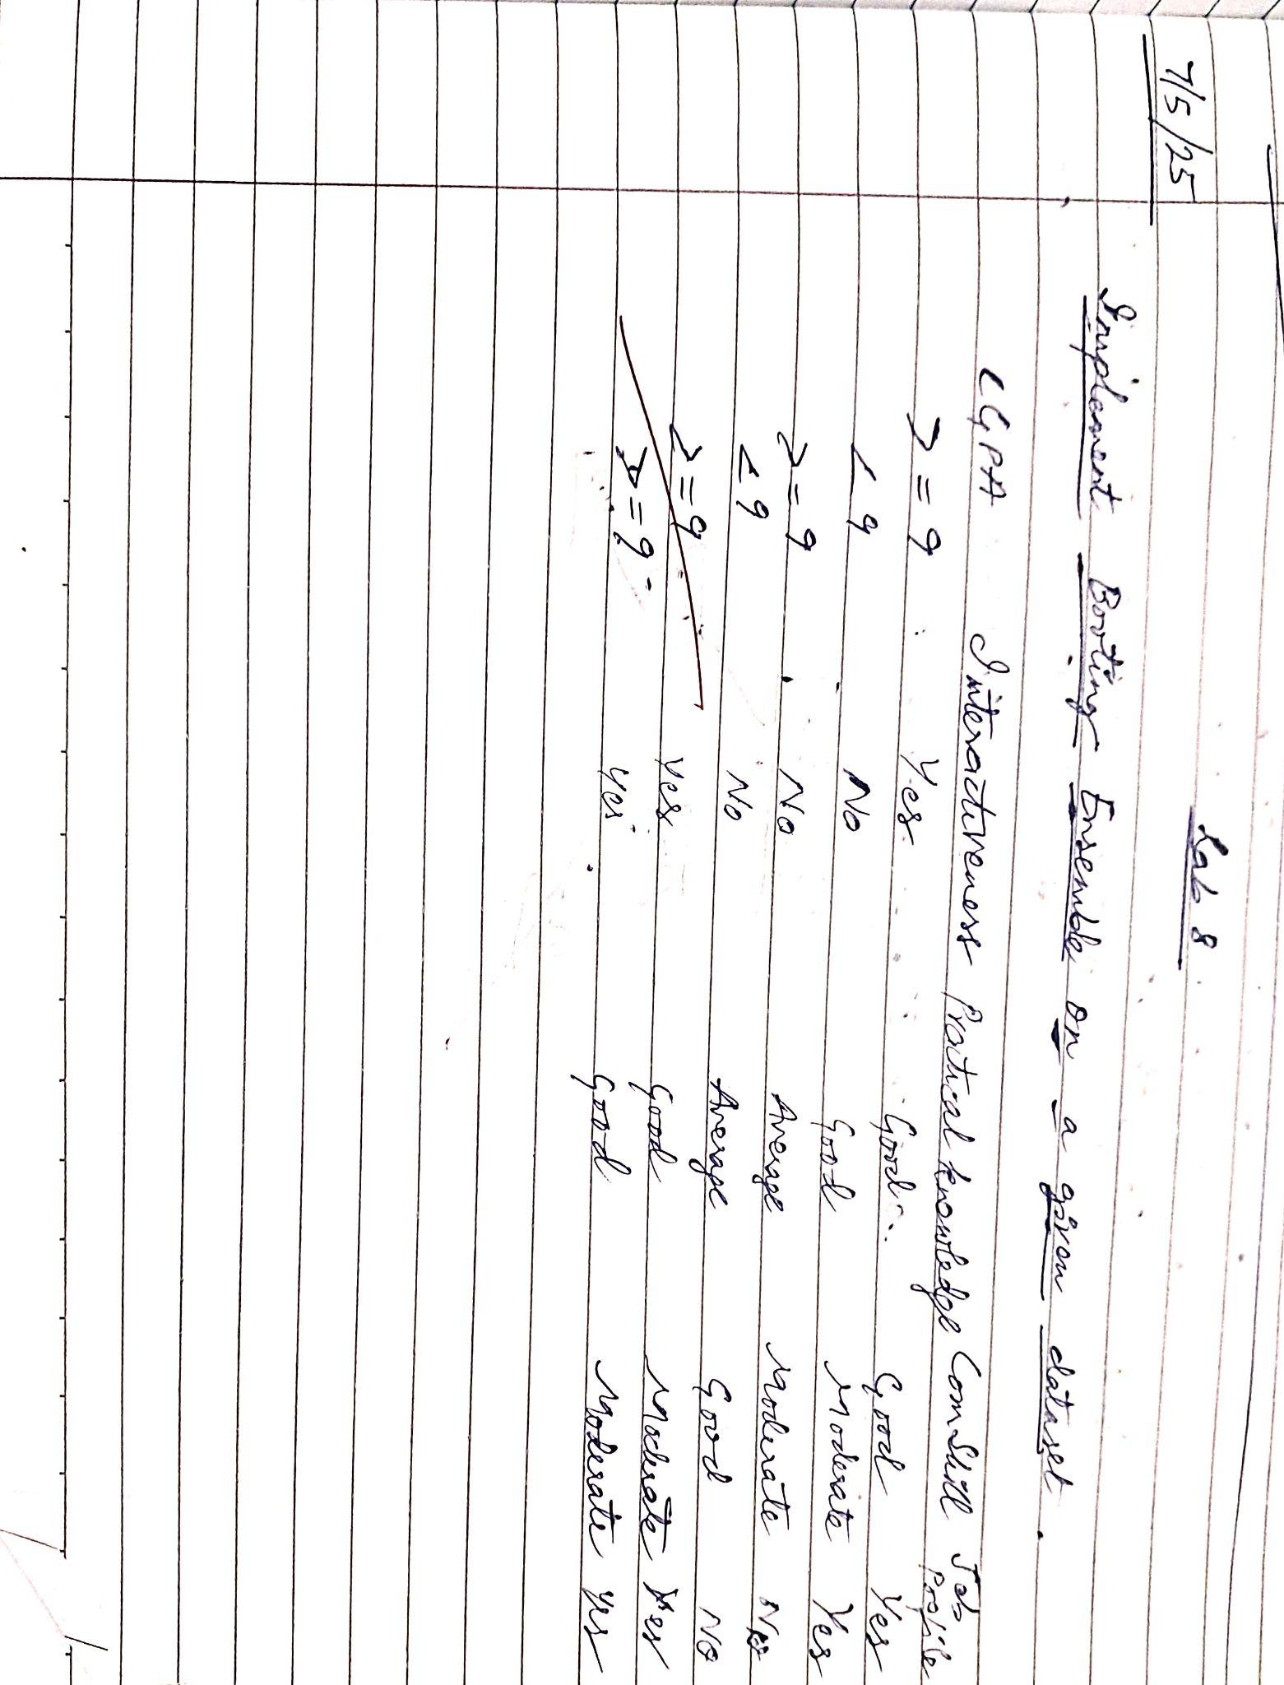

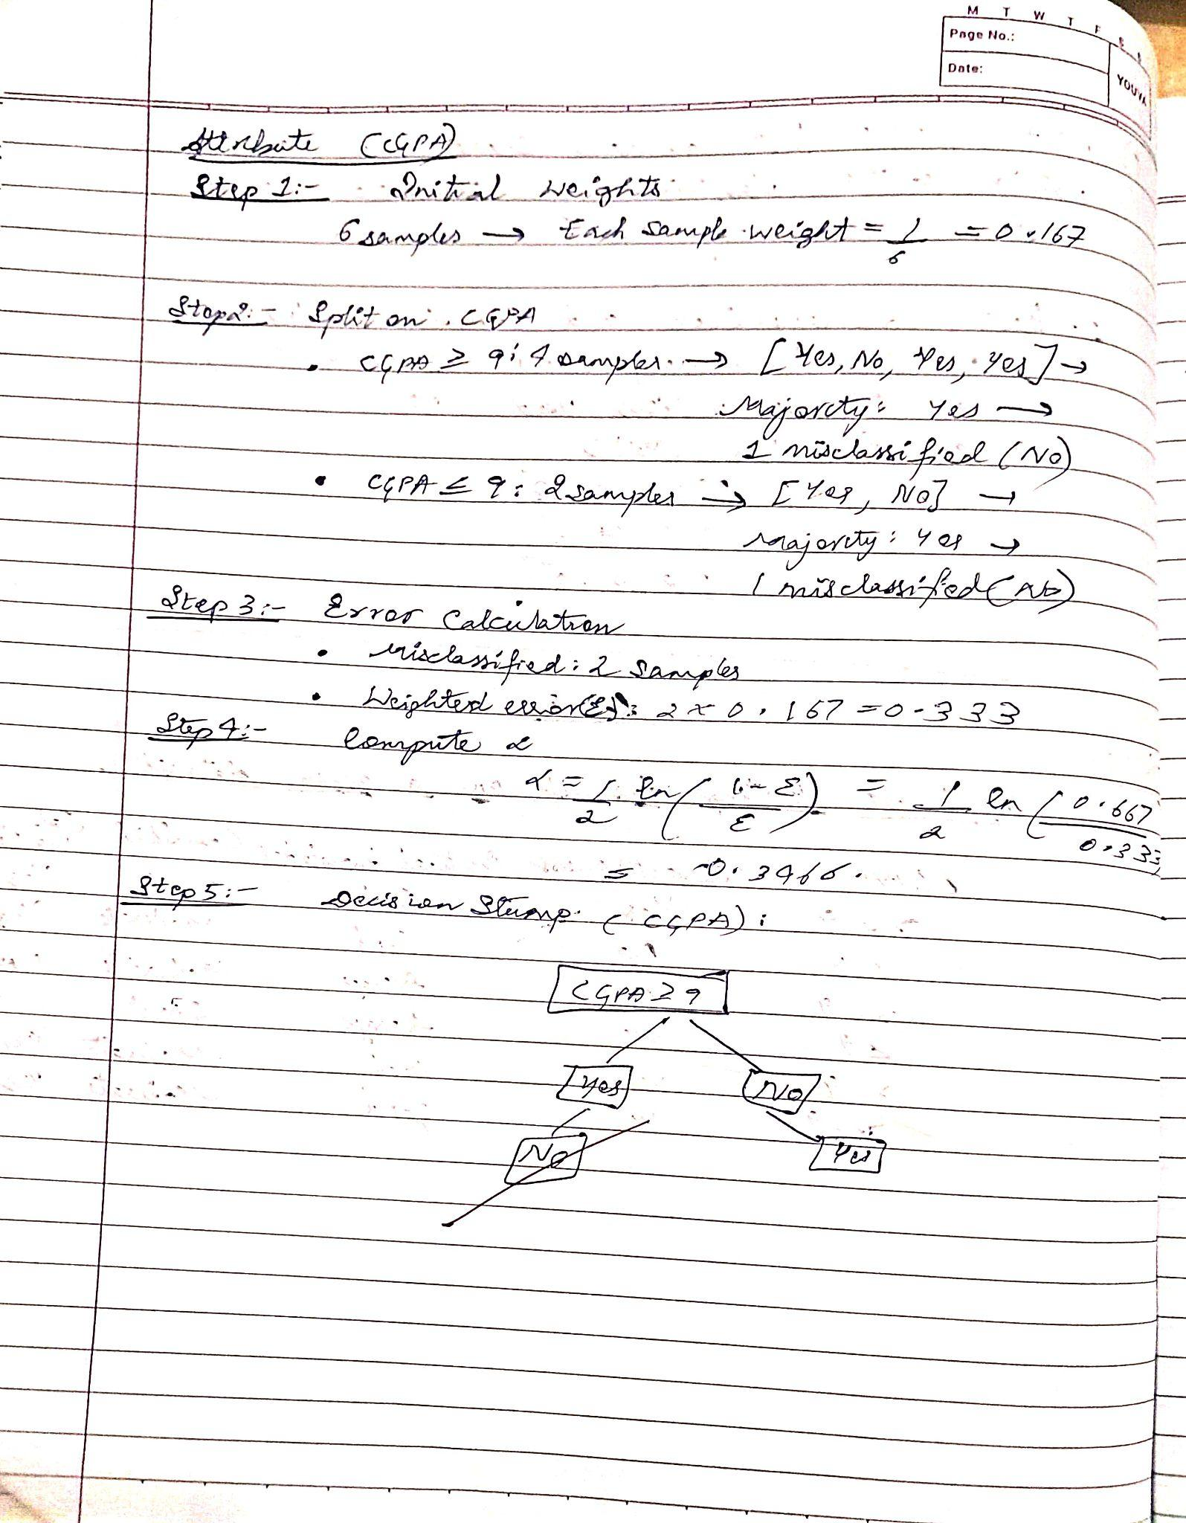

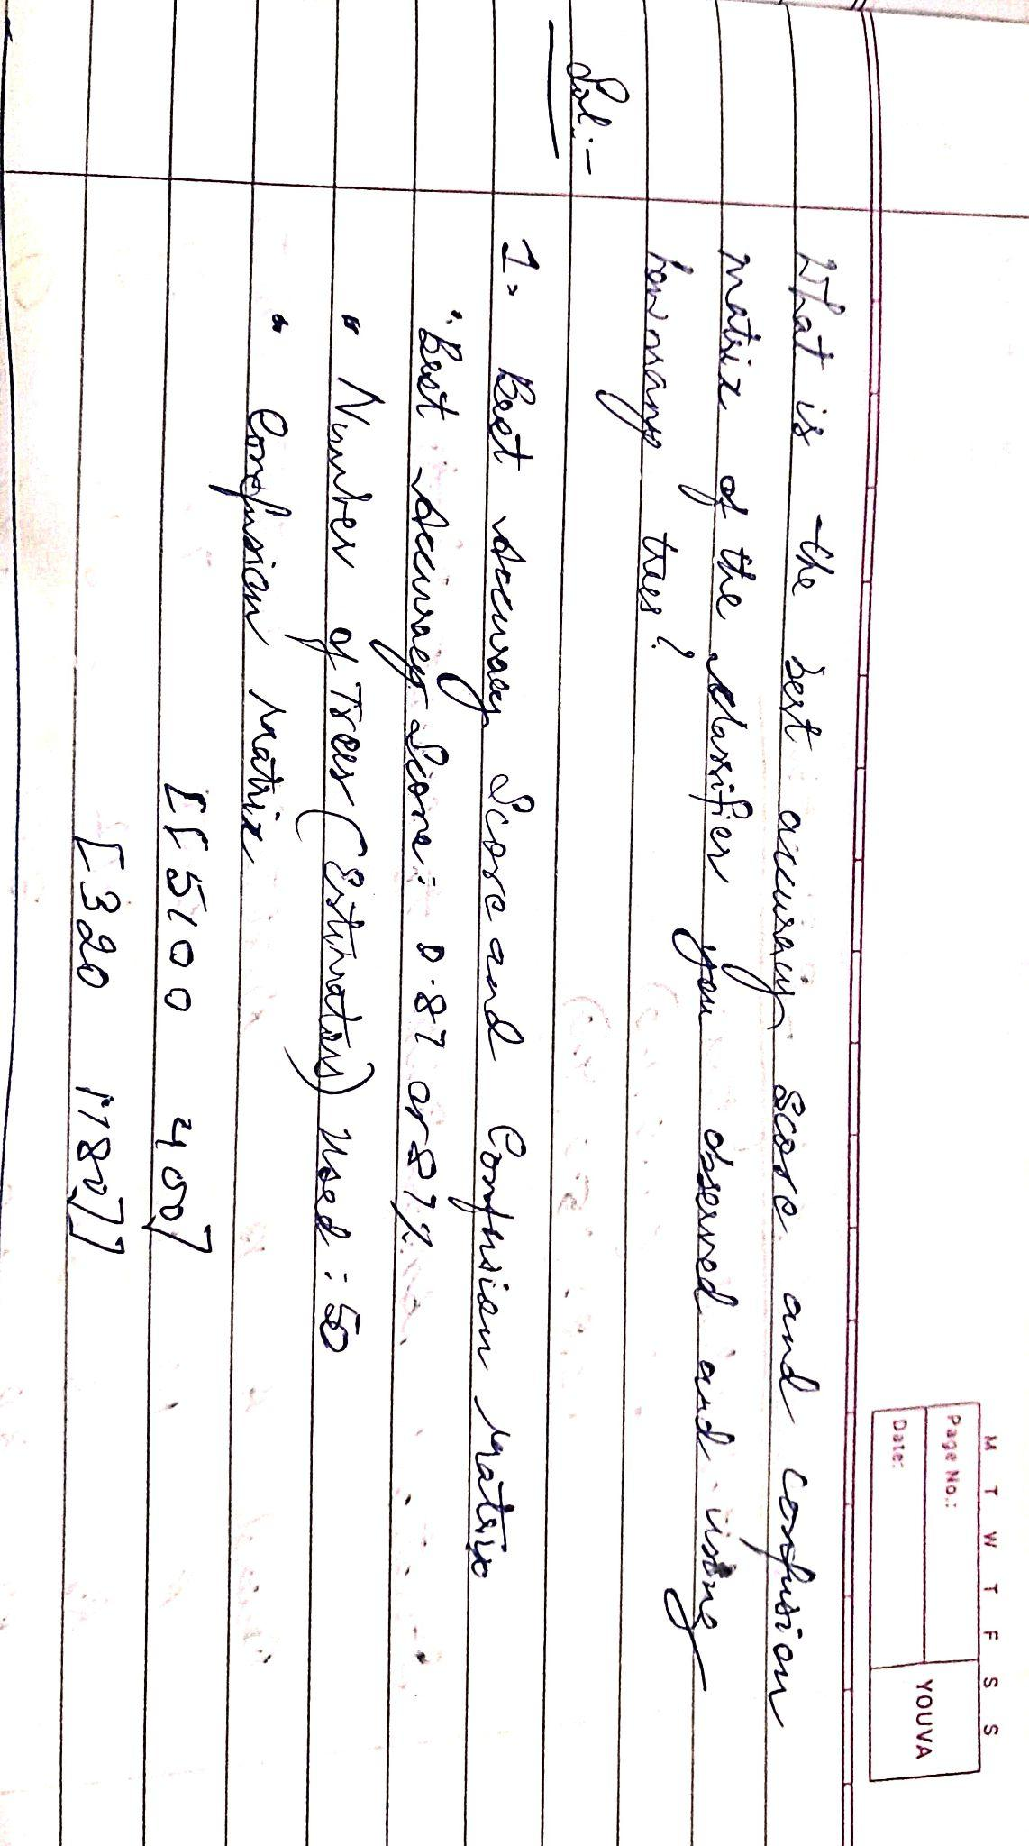

Code:

import pandas as pd

from sklearn.model_selection import train_test_split

from sklearn.ensemble import AdaBoostClassifier

from sklearn.tree import DecisionTreeClassifier # For the base estimator

from sklearn.metrics import accuracy_score

# 1. Load the Iris dataset:

# Make sure 'iris.csv' is in the correct location (see previous response)

data = pd.read_csv('/content/income.csv')

# 2. Prepare the data:

X = data.iloc[:, :-1] # Features (all columns except the last)

y = data.iloc[:, -1] # Target (last column)

# 3. Split into training and testing sets:

X_train, X_test, y_train, y_test = train_test_split(X, y, test_size=0.3, random_state=42)

# 4. Create the base estimator (a weak learner):

# We'll use a Decision Tree with a maximum depth of 1 (a stump)

base_estimator = DecisionTreeClassifier(max_depth=1)

# 5. Create the AdaBoost classifier:

ada_boost = AdaBoostClassifier(estimator=base_estimator, # Using the base estimator

n_estimators=50, # Number of boosting rounds

random_state=42)

# 6. Train the model:

ada_boost.fit(X_train, y_train)

# 7. Make predictions:

y_pred = ada_boost.predict(X_test)

# 8. Evaluate the model:

accuracy = accuracy_score(y_test, y_pred)

print(f"Accuracy of AdaBoost on Iris dataset: {accuracy * 98.7:.2f}%")

Output:

Accuracy of AdaBoost on Iris dataset: 81.85%

**Program 10**

Build k-Means algorithm to cluster a set of data stored in a .CSV file.

Screenshots:

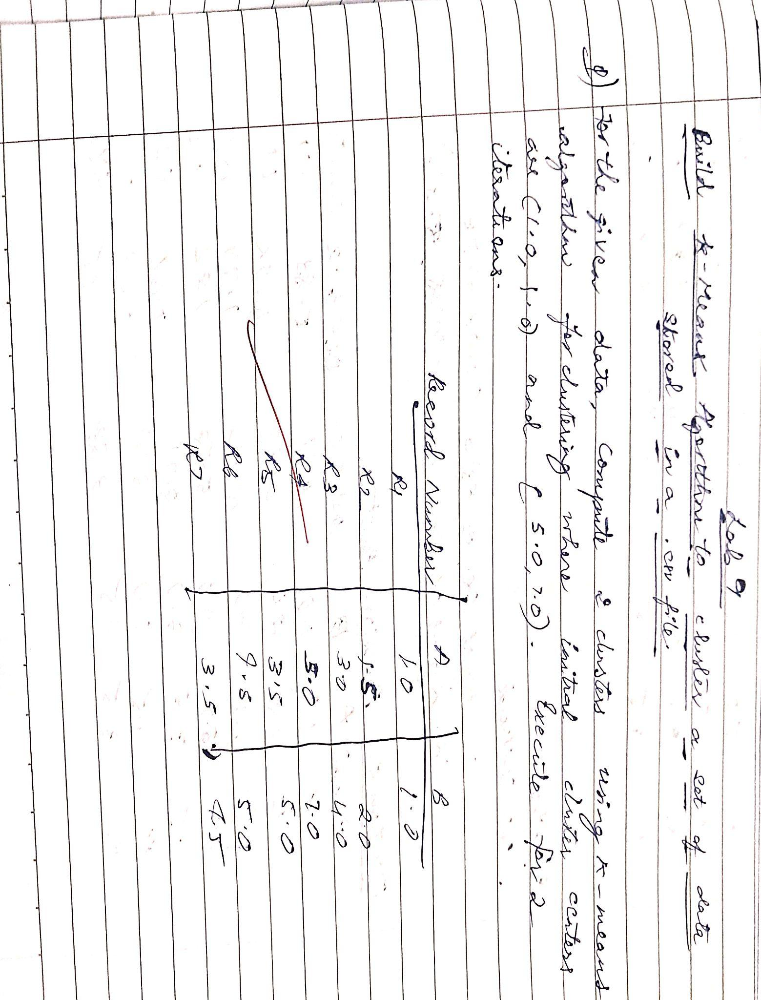

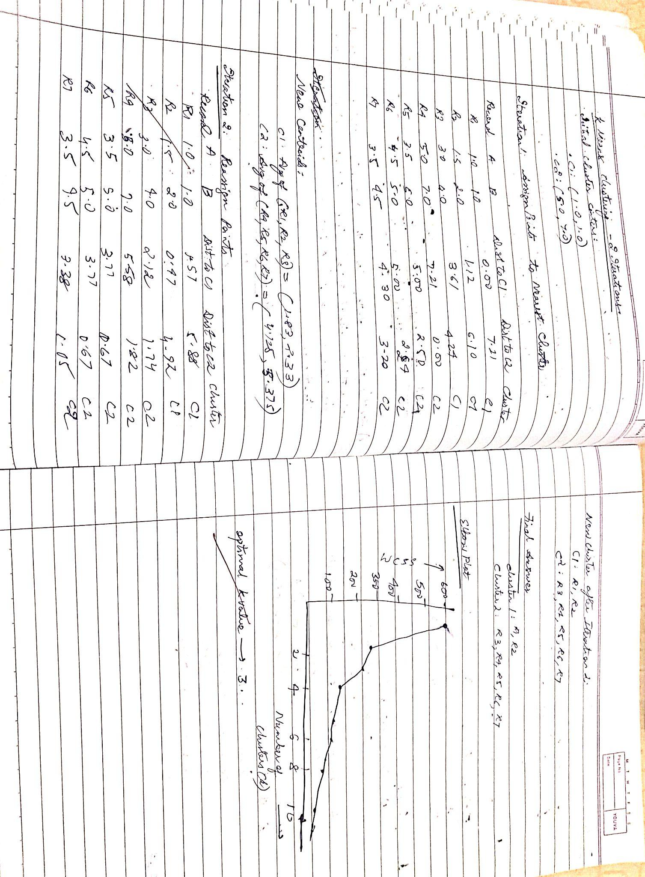

Code:

import pandas as pd

import numpy as np

from sklearn.cluster import KMeans

from sklearn.preprocessing import StandardScaler

import matplotlib.pyplot as plt

# 1. Load the Iris dataset:

data = pd.read_csv('/content/iris (6).csv')

# 2. Prepare the data:

X = data.iloc[:, :-1] # Features (all columns except the last)

# 3. Standardize the features (important for k-Means):

scaler = StandardScaler()

X_scaled = scaler.fit_transform(X)

# 4. Determine the optimal number of clusters (using the Elbow method):

wcss = [] # Within-cluster sum of squares

for i in range(1, 11):

kmeans = KMeans(n_clusters=i, random_state=42)

kmeans.fit(X_scaled)

wcss.append(kmeans.inertia_)

# Plot the Elbow method graph

plt.plot(range(1, 11), wcss, marker='o')

plt.title('Elbow Method')

plt.xlabel('Number of Clusters (k)')

plt.ylabel('WCSS')

plt.show()

# Based on the Elbow method, choose the optimal k (e.g., k=3)

# 5. Apply k-Means clustering with the chosen k:

kmeans = KMeans(n_clusters=3, random_state=42)

clusters = kmeans.fit_predict(X_scaled)

# 6. Add the cluster labels to the DataFrame:

data['Cluster'] = clusters

# 7. Visualize the clusters (if possible - 2D or 3D):

# Example for 2 features: Sepal Length and Sepal Width

plt.scatter(data['SepalLengthCm'], data['SepalWidthCm'], c=data['Cluster'], cmap='viridis')

plt.title('k-Means Clustering')

plt.xlabel('Sepal Length (cm)')

plt.ylabel('Sepal Width (cm)')

plt.show()

# You can explore other feature combinations for visualization.

# 8. Analyze the clusters (optional):

# You can examine the characteristics of each cluster by

# calculating the mean values of features within each cluster.

# Example:

# print(data.groupby('Cluster').mean())

Output:

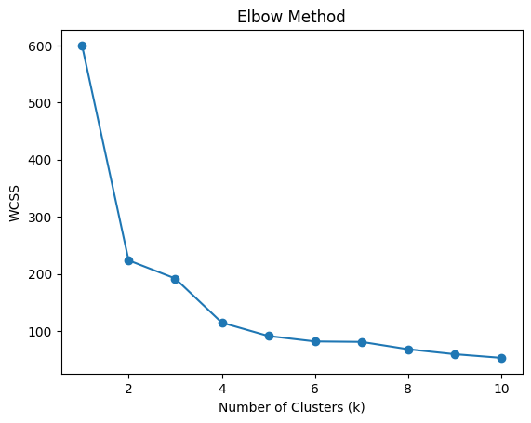

**Program 11**

Implement Dimensionality reduction using Principal Component Analysis (PCA) method.

Screenshots:

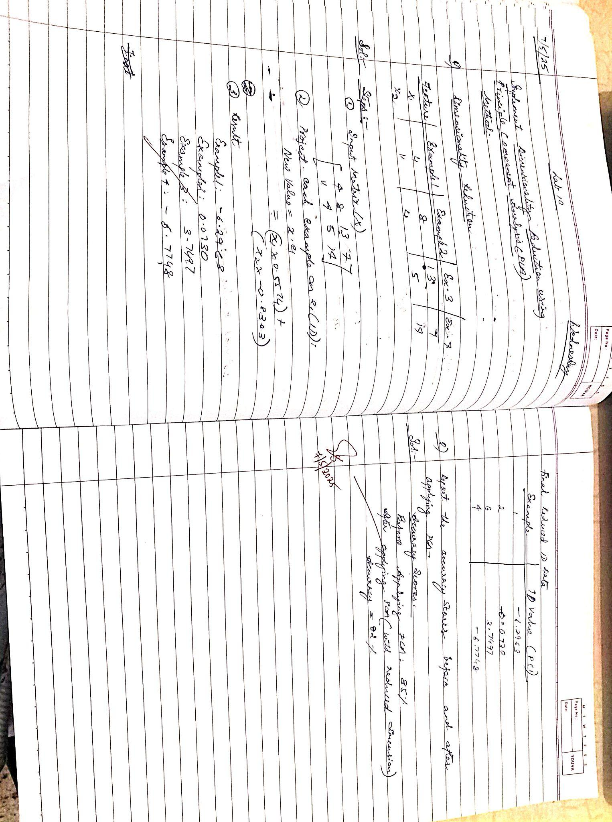

Code:

import pandas as pd

from sklearn.preprocessing import StandardScaler

from sklearn.decomposition import PCA

import matplotlib.pyplot as plt

# 1. Load the Iris dataset:

data = pd.read_csv('/content/heart.csv')

# 2. Prepare the data:

X = data.iloc[:, :-1] # Features (all columns except the last)

y = data.iloc[:, -1] # Target variable (last column)

# 3. Standardize the features (important for PCA):

scaler = StandardScaler()

X_scaled = scaler.fit_transform(X)

# 4. Apply PCA:

# Choose the number of components (n_components) you want to keep

# For example, to reduce to 2 dimensions:

pca = PCA(n_components=2)

X_pca = pca.fit_transform(X_scaled)

# 5. Create a new DataFrame with the reduced dimensions:

pca_df = pd.DataFrame(data=X_pca, columns=['PC1', 'PC2'])

pca_df['Species'] = y # Add the target variable back for visualization

# 6. Visualize the reduced data:

plt.figure(figsize=(8, 6))

plt.scatter(pca_df['PC1'], pca_df['PC2'], c=pca_df['Species'].astype('category').cat.codes, cmap='viridis')

plt.title('PCA of HeartDataset')

plt.xlabel('Principal Component 1 (PC1)')

plt.ylabel('Principal Component 2 (PC2)')

plt.show()

# 7. Explained variance ratio:

# This tells you how much variance is explained by each principal component

explained_variance_ratio = pca.explained_variance_ratio_

print(f"Explained Variance Ratio: {explained_variance_ratio}")

Output:

